UNIT-4
INTRODUCTION TO TALLY

Tally: 9 Features and Introduction

Introduction:

Tally is one of the most simple and complete business solutions available in the world. Anybody who has a basic Knowledge of accounts can use Tally. It is easy to learn, configure and use Tally. Tally is not only a computerized accounting package but it is Accounts on computers.

Having created a Company, on loading tally every time, you get the Gateway of Tally. This is the entry point to get to the desired part of the tally you want to work with. So, it is important to get familiarized with the various elements of tally gateway.

Note: Any previous version tally user like tally 8.1, Tally 7.2, Tally 6.3, Tally 5.4, and Tally 4.5 can 4.0 upgrade to Tally 9.0.

An Overview:

Tally 4.5: Dos base and accounts only.

Tally 5.4: Windows base and account with inventory.

Tally 6.3:
Tally Vault: Tally provides additional security, by opting to tally vault you many keep any company’s data in encrypted form instead of normal.

Tally Audit & Drill Down Display: Tally allows users to drill clown from any report to lower levels till the actual voucher that contributed to the Report and trace back the same way. During Display, Tally permits to Modify, Add, Delete, Cancel a voucher and any changes made in the voucher is reflected real time at all revels.

Online Help: Tally 6.3 has built in ‘Context Sensitive Help’. You just need to press the ‘Help’ button while in Tally, and it will bring up the relevant topic.

Print Preview: This facility helps you check report formats and layouts.

Direct Access to the Internet: Tally 6.3 allows you direct access to the web, from within Tally.

Tally 7.2:

VAT: Features of Vat in Tally 7.2
VAT is completely integrated with Tally 7.2 the VAT functionality in Tally 7.2 supports the following features.

Making it easier for computation:
- Quick & easy setup
- Fast & error-free voucher entry
- Pre-defined list of sales & purchase Classifications
- Complete tracking of each transaction till annual returns
- Printing of Tax invoice
- VAT computation returns management
- Monthly Return

eTDS: The TDS functionality in Tally supports the following features:
- Simple and user-friendly.
- Quick and easy to set up and use.
- Accounting for tax on Partial/full payment of bills.
- Flexibility for auto and manual calculation of TDS.
- Complete tracking of each transaction from deduction to payment.
- Challan management and printing for prompt and accurate filing of tax.
- The Auto allocation feature prevents error-prone data entry and helps transactions faster.
- Form 16 A management:
- Can be printed for a transaction
- Can printed for a period
- Can be printed yearly
- Allows multi-Party printing
- Exporting of data in NSDL Compliant TDS file format.
- Electronic format (e-TDS return) With Form 26Q, Form26, Form27, A which will be validated by the utility, provided by the government.
- Generates form 16A, TDS Chelan, TDS computation and Payable reports.

Service Tax: Service tax integrated in Tally takes care of your service tax transactions. It eliminates error-prone information, incorrect remittance, penalties, interests, compliance issues, etc. Service Tax in Tally needs a one-time configuration for service tax features to be activated.

GAR-7 Challis, Input Credit From, ST3 Report and ST3-A Report.

TCS: TCS enabled with E-TCS capability, Print Form 27D, From 27B, TCS Challan, TCS Challan Reconciliation, TCS Payable Report, TCS Ledger Outstanding Reports, eTCS.

Tally 8.1:
Excise for Traders:
- Generation of Excise Invoice for Trader
- Tracking of Purchase Invoice during sales and ability to pass on Convert Credit
- Generation of Quarterly Returns(Form2)
- Generation of Excise Stock Register (RG23D)

FBT:
- Accounting for FBT
- Computing FBT Payable
- Generating Challans (Quarterly)
- Filing FBT Returns (Yearly)

Tally 9 Releases 1.2:
Payroll: Lets you automate the management of your employee records including is and employment contract Management. This feature also offers automatic calculation of salaries and pay slip generation.

Job Costing: enables you to generate profitability statements for each project executed, including financial and material resource apportionments, wherever applicable.

POS Invoicing: allows faster data entry and printing on 40 column continuous stationery. It also provides barcode support.

Data Synchronization: helps you synchronies and update data across multiple locations. This enables fast and easy exchange of business information, between offices and branches, across various geographies.

Consolidation of Companies: enables grouping of companies and provides consolidated reports. Changes done in any constituent of Branch Company are automatically updated in the grouped information.

Unlimited Levels of Classification: facilitates ledger classification and reclassifications as required. It also enables easy viewing and analysis of information; thus helping you makes informed decisions.

Advanced MIS: helps you compare information in order to understand and analyze performance levels for various periods of divisions. It helps you study and understand the buying patterns of customers, so that you can channel your resources to specific segments, Periods of customers. It also helps you analyze cash flow situations.

Tally 9 Releases 2.12:
Service Tax:
- A Service tax payment entry with more than 200 bill references is now being accepted.

FBT:
- In FBI Filters, a new section Chelan Details has been added to provide information pertaining to the Bank Challan No.; Challan date, Cheque/DD No., Bank Name and BSR Code. These details will be captured and displayed in the FBT Challan Reconciliation screen.
- In case the challan Details are provided while reconciling, the same will be updated in the Challan details of FBT filters. The cheque/DD number entered in FBT filters is captured in FBT Challan.

POS:
- POS Register opens with Current day transactions. This Feature is useful when a large volume of retail invoicing is done in a single day.

VAT:
- The additional tax and Cess on vat for Gujarat & Kerala are now incorporated in the VAT computation report.

Service Tax:
- Adhering to the new notification dated April 1, 2008, the option ‘Credit Adjustment (%)’ has been withdrawn from Company Service Tax details screen.
- The exemption notification number will not be displayed in the narration field as the option to display/ alter the same is provided in both accounting and item invoicing mode.
- The Abatement Notification Number and Abatement percentage will be picked by default from the statutory master in service ledger master but the same can be edited in the Service Tax Details sub-screen while invoicing.
- In GAR7 (Payment) voucher, two new fields Challan No. and date have been provided. The same will be captured and printed in GAR 7 Challan and ST3 report.
- In company service Tax Details screen, a new list of assessed types has been provided to select the Type of origination and the fields is Large tax Payer, Large Tax payer unit as well as premises code have been introduced.
- Services provided or taken from third party can be accounted as pure agent services by enabling Is pure Agent service in the service tax details screen.
- Abatement details like abatement notification No. and percentage in statutory masters are populated in service ledgers. These abatement details can be altered while creating ledgers and invoicing.

Payroll:
- TDS pay head can now be grouped under duties & taxes and salary payable pay head under current liabilities.

Import/Export:
- An additional Field output sheet name is added in the export screen when the data is being exported in the excel format.

Excise for Dealers:
- While altering an Excise Sales/purchase invoice, the message ‘Memory Access Violation’ was being displayed on moving the cursor to delivery note field of party details screen.

Synchronization:
- Time log is provided for the synchronization process.

Export of Statutory Report to Excel:
- On exporting the data to an existing file in MS excel, a new option Update Excel, a new option update existing file? Is provided to ensure that only additional data is added to the excel file and the contents of the entire sheet is not overwritten.

Features of Tally 9.0:

Speed: A Tally user can get any reports instantaneously for any date/period and can toggle between reports, either accounting or inventory or even from one company to another company. If one is viewing a daybook for 1st of April he can immediately select 31st of March of the next year and will be able to see the daybook for that date only at the click of button.

MIS: Tally has the power to generate management information, which would help the management in taking correct quick decisions. This in turn would enable faster growth of business.

No Codes: Tally was the first accounting package in the world to introduce the No codes concepts for Accounts. Tally accepts alphanumeric characters for accounts and inventory masters and hence any accounts of stock items can be created and identified by their names.

Real Time: Tally updates all reports (from day book to balance sheets) as and when the transactions are entered and hence do not need any back end of day/period end process to be done.

Online Help: Tally provides user-friendly context sensitive online help for the user.

Advance Features:
- Simple Accounting
- Basic Financial Management
- Advanced Inventory Management
- Technology Advantages
- Multilingual
- VAT/Service Tax/eTDS /Dealer Excises/FBT/TCS
- Payroll
- Point of Sale (POS)

Tally Gold for multi user: If your company runs on a local area network (LAN) and requires that Tally by installed on all the computers connected to the network then you need to activate multi-user license i.e. Tally Gold. In this process, on computer is designated as the license server and all others as license clients.

Tally Silver for single user: Single-user licensing allows the deployment of tally on single computer with an option of activating it online or offline. You can also choose

To use the same Tally license on another computer, by surrendering the license activated on a computer and reactivating it on the other.

Company Creation

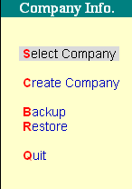
Company Creation:

In Tally, the term Company represents any entity for which an independent set of accounts is maintained It may be a Company, Partnership Firm, H.U.F, Individual, NGO, or even a Branch Office for which a set of Account is maintained. So, in Tally the Term Company is an entity for which you maintain a set of Accounts. In Tally 9, creating a company involves providing basic information about the company whose books of accounts are to be maintained in software. In the Gateway of Tally press, Alt+F3 keys or click Company Info. Option.
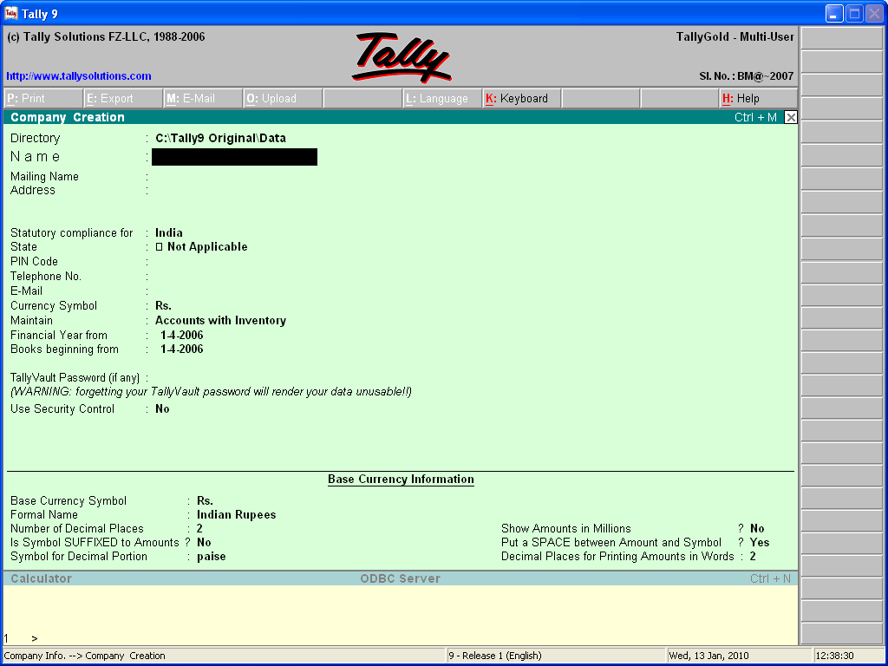

Working with Company:

Directory: It is the location where the company will be stored on the hard disk. To change the location press backspace key and type the full path of the location; if the folder in which you want to store the data does not exist Tally will create the folder itself.

Name: Type the name of the company you want to create. This name will be displayed in all internal reports. Name should be unique.

Mailing Name: Type the company name you want to print in all the external reports like invoice etc. it can be different from the company name and need not to be unique.

Address: Type the complete address of the company. Address will also print in all external reports.

Statutory Compliance for: Select the country from list of countries

State: Select the state from pull down list.

Pin Code: Type the pin code of the company address.

Telephone No.: Enter the Telephone Number of Company.

E-Mail Address: Type the E-Mal address of the company. Tally will pick this address for Internet utilities itself.

Currency Symbols: Type the symbol of currency you want to use (e.g. Rs. For the Indian currency)

Maintain: Select Accounts only to maintain only accounts, mean you cannot maintain the stock simultaneously. Select Account with Inventory here and you can maintain accounts as well as stock simultaneously.

Financial Year From: Enter the date of beginning of the financial year i.e.1st April and the year from which you are starting your accounts on Tally. You can select any other date also; Tally would close your accounts on the date exactly completing twelve months from the date you have defined. However you can see the reports of a particular period by selecting the period from current Period Option.

Books Beginning From: This is the starting date from which you want to maintain your accounts. Tally will not accept any voucher entry of before this date.

Tally Vault Password: Tally vault Password will make the name of the company in encrypted form. Extra care should be taken to given the Tally vault Password as if you forget the password you will loose your data.

Use Security Control: Press Y if you want to protect your company through password.

Name of Administrator: Define the user name.

Password: Give the password you want to retain; it will be in encrypted form.

Repeat: Retype the password you have given in the last field.

Tally will ask for both of the above whenever you want to start work with the company. These are case sensitive. If you forget your password then you cannot work with that company unless and until you enter the right password and username.

Tally Audit Features: This will enable you to track the changes in data of your company, press Y to activate this feature.

Press N to continue without any security measure.

Press enter or Y to accept the data. Your new company will be created.

Company Information Menu:

Select Company: To Select or load a company

Shut Company: To shut a company

Create Company: To create a company

Alter: To Alter a company

Change Tally Vault: To change the vault password of to provide Tally Vault Password if you did not give it at the time of company creation. In both cases instead of changing / creation of new password, Tally will create a new company with new tally vault password.

Backup: If you want to take data of tally to some other storage device i.e. floppy, Compact disk etc.

Restore: When you want to get data of tally from some other computers.

Buttons:
F1 : Select Company

Alt+F1 : Shut Company

F2 : Date

Alt+F2 : Change Period

F11 : Company Features

F12 : Company Configuration

Alteration: To alter the profile of the company select at Gateway of Tally – F3> Alter
Select company (if more than one company selected).Make necessary changes you require, accept data directory, as it will be invisible at Company Alteration Screen. Press Ctrl+ A to save the changes.

Deletion: At company Alteration Screen Press Alt + D to delete the company it will ask for the confirmation art you sure, press Y to delete the company.

Selection of Company:
- To select the company press F1 at Gateway of tally. List of companies created so far in the current directory will appear.
- If you want to change the data directory press Shift +Tab or Backspace and type the full path of the directory. List of companies existing in that directory will be displayed.
- Now, select the company and press enter. It will ask for username and password if any given, enter them and company will display in the list of company at Gateway of tally.

Shut Company: To close the selected company press Alt + F1 at Gateway of Tally of select shut Company in comp. Info. Menu. List of selected companies (if multiple companies are selected) will be displayed. Select the company you want to close. Press enter.

GROUPS IN TALLY

Creating Groups in Tally 9

Account Groups: Account Groups are just a convenient method of organizing the large population of Ledger Accounts into a tree-structured Tally classifies and identifies account heads according to their nature. This helps in presenting summarized information. Tally provides us 28 reserved groups. These groups are auto create a new company. These Groups cannot be deleted. Out of 28. Groups 15 are Parent/Primary groups and rest of 13 groups are called secondary/Sub group. These 13 groups belongs to the above 15 groups. Groups are related with.

- Income
- Expenditure
- Assets
- Liabilities.

Creating a Group: If you are creating groups for the first time, it is advisable to configure them before you proceed. In the Gateway of Tally click Accounts Info. Option. In this menu click Groups option. In the Group option menu under the Single Group click the Create option. The Group Creation screen displays.

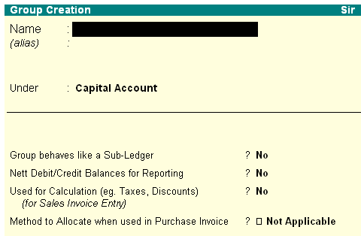
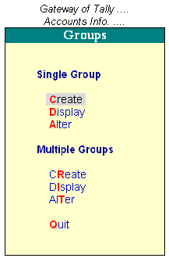
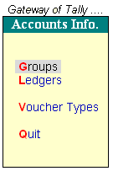

Name of Group: Enter the name of the Group to be created.

Alias: Enter an alias name to allow access to the group using the Alias in addition to its name or leave it blank. For example, for Administrative expenses, you can enter Office Expense.

Under: Specify under which existing (Parent) group the sub-classification is required. If it is a new primary group.

Additional Information
Group behaves like sub-ledger? : this option is applicable to Sundry Debtors group, you can set this to Yes to display Sundry Debtors without Ledger break –up in statements.

Nett Debit/Credit Balances for Reporting? : Setting this option to yes will display either the net debit or credit balance in the report (whichever is higher).

Used for Calculation (e.g. taxes, discounts)? : This option is used if ledgers under this group would have percentages for discounts/taxes to be used for invoice entry. This gets reflected while passing voucher entry in Invoice mode; it uses the automatic calculation capability.

Method to locate when used in purchase invoice: Select the appropriate allocation method from the list.

Group Display: To display a group select the following.

Gateway of Tally > Acc. Info > Group > Single Group > Display.

Modification/ Deletion of Group: To modify of delete a group select

Gateway of Tally > Acc. Info > Group > Single Group > Alter.
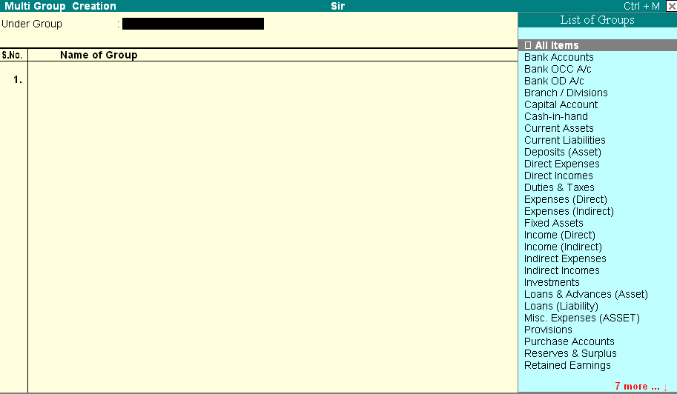
Multiple Groups:

If you want to Create/Display/Modify more then one group at a time you can use multiple groups. It will speed up your work. Select the following.

Multiple Group Creation: In multiple group creation, the sub-groups will automatically inherit the characteristics of their parent groups. In the

Gateway of Tally clicks Accounts Info. Option. In this menu click Groups option. In the Group option menu under the Multiple Group click the Create option. The Multiple Group Creation screen displays.

Name of Group: enter the name of the group.

Under: If you select any group other than All Items in the Under Group field, then this column is filled in automatically with the selected Group name and the cursor skips this column. This speeds up data entry.

Introduction of Ledger:

A Ledger is the actual account head to which you identify a transaction. In Tally, you pass all accounting vouchers using Ledgers. However, all Ledgers have to be classified into Groups. Hence a thorough understanding of account classification in important for working with Ledgers.

Creating a Single Ledger: The creation of Ledger depends on the features you opt for in the F11: Features of your company and F12: Configure. It is advisable to set F11: Features and configure the F12: Configure screen before creating any Ledgers.

Tally automatically creates two Ledger account namely, Cash (Under Cash-in-Hand) and Profit and Loss Account (direct Primary Account). You need to create all other accounts heads. There are no restrictions in Ledger creation except that you cannot create another Profit & Loss A/c
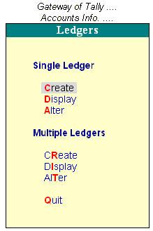

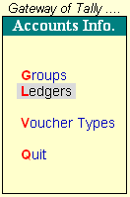

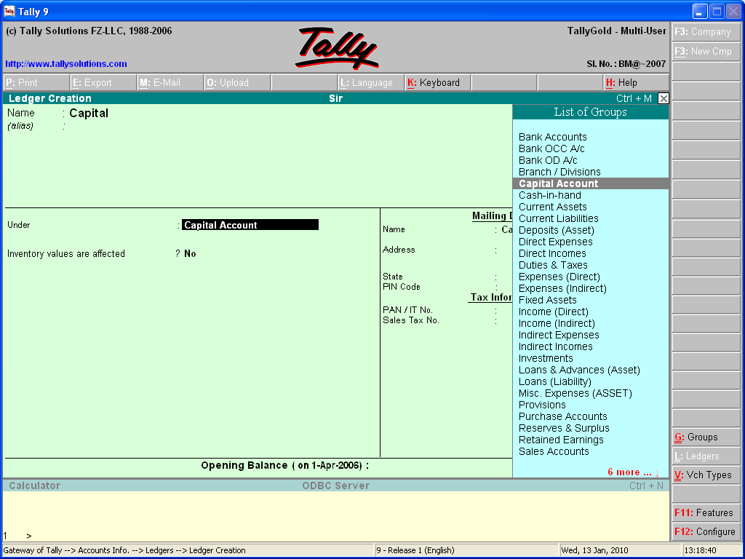

Name: Enter the name of the account. You can provide the full name of the account.

Alias: Enter an alias name if required. You can access the Ledgers using the original name or the alias name.

Group: All accounts must be classified under their appropriate Groups. Select the Group under which the Ledger is created from the List of Groups.

A Group is not important by itself, but because it controls the usage of Ledger accounts. A wrong classification would affect the treatment of the Ledger account in final statements and during voucher entry.

Opening Balance: If yours is an existing company whose books you are entering onto Tally, Opening Balance would be applicable in circumstances such as when the Ledger is an asset or a liability and if it has a balance in the account as on the date of beginning of books in Tally. Tally recognizes normal accounting principles of debit balances for Assets and credit balances for Liabilities.

Ledger Display: Display option does not permit any modification. Here you can use pgup /pgdn key to display next of previous ledger.

Gateway of Tally > Accounts Info. > Ledgers > single > Display > Select Ledger.

Creating Multiple Ledgers: You can create multiple Ledgers at a time in this mode. You can first create a Ledger under each group in single Ledger mode and then the rest of the Ledgers in multiple modes.

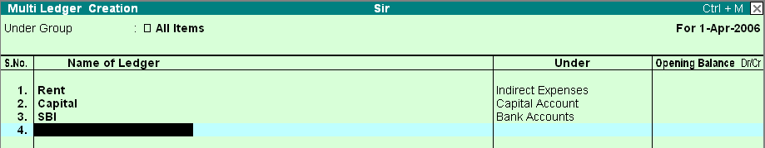

Under Group: Select the name of the group under which you want to create the Ledgers from List of Groups.

Name of Ledger: Enter the name of the Ledger.

Under: This field defaults to the parent group selected in Under Group. The selected group in Under Group gets displayed here automatically and the cursor skips this column.

Opening Balance: This is the balance remaining when you first enter your books on Tally i.e., the date of beginning for books. If you have opted to maintain balances bill – by – bill, you must give the bill details.

Advanced Information:

(ONLY if the ledger is maintained in base currency). (The relevant options should have been activated in the company features)

Maintain Balances Bill-by-bill (Yes/No): Yes, if you wish to give a bill-wise break-up of the ledger balance including the opening balance. You may give any number of bills here. The option here would also determine the ability to track transactions according to bill references.

Date: Enter the date of the bill would naturally be prior to the accounting period.

Name: Give a name to which you can later refer when adjusting the bill. Typically, you would give the bill no or document number.

Due Date (or Credit days): Give the credit period of the date when the bill is due. You many give either. Tally automatically calculates the other.

Allocate to Cost-Centers (Yes/No): Set it yes if you want to cost center allocation in this ledger.

Inventory values affected? : This is applicable only in case your accounts are integrated with inventory. Accounts like sales and purchases would normally affect inventory values in which case set this field to Yes.

Inventory Information:

If you want to maintain how many quantities you had purchased/sold and how much you have in your stock, you have in your stock; you can do this in Tally. In company creation/ alteration menu you have to select at maintain field accounts with inventory option.

Using Stock Groups: Stock Groups in Inventory are similar to Groups in Accounting Masters. They are helpful in the classification of Stock Items. Classification is based on some common behaviors. Stock Groups enable easy identification and reporting of Stock Items in statements.

Creating a Stock Group:

Gateway of Tally > Inventory Info. > Stock Groups > Create

(Under Single Stock Group). The stock group Creation screen displays.

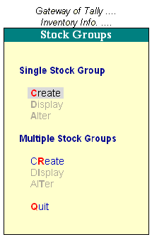
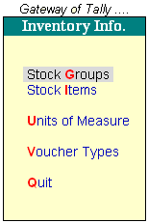
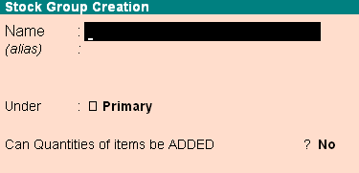

Name: Enter the name of the Stock Group to be created.

Under: Specify whether it is a primary group of a sub-group of another group,

Can quantities of items be ADDED? : This field pertains to information on measuring the units of the Stock Items that you would categories under the Stock Group. You cannot add quantities in Kgs to quantities in Pcs.

Creating a Stock Item: For creating stock items open the

Gateway of Tally > Inventory Info > Stock Item >Single Create.

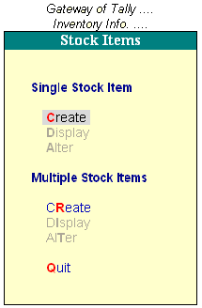
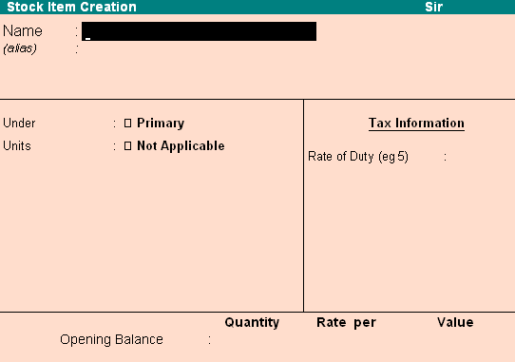
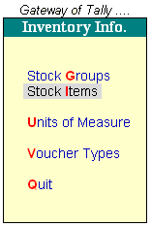
Name: Give the name of the stock item.

Alias: This is for alternative names of stock items.

Under: Specify the group to which it belongs.

Units: Give the unit of measurement of the item here. You would normally use this unit for trading in this item.

Creating Godowns: You may want to distinguish between stock held on-site and at the warehouse, and this can be done by creating two separate stock locations. You may even amend Tally’s default location and create a new location for the warehouse.

Create a Location:

Gateway of Tally > Inventory Info. > Locations > Create
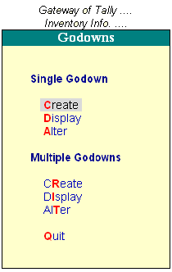

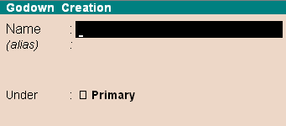
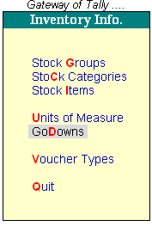

Name: In the Name field, give the name of the location.

Alias: Give an alias for the name, if required.

Under: Give the location under which this location is to be sub-grouped.

Allow Storage of Materials? : Tally permits you to create a location/godown where you may not store materials at all but treat it as a virtual location.

Create a Unit of Measure:

Gateway of Tally > Inventory Info. > Units of Measure > Create

Type: Symbols are of two types: Simple and Compound. Simple units are considered as stated by you and Tally just checks for duplication and nothing else. If you wish to give unit symbol that are single and not a combination of other units, select Simple.

Symbol: Give the symbol of the unit, e.g., No., Mtrs. This symbol given by you is used in all displays and printouts.

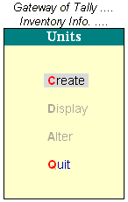
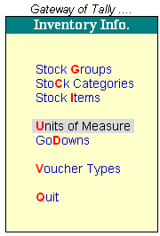
Simple Compound
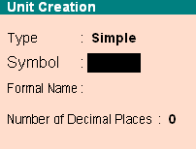
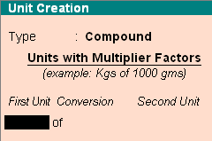

Formal Name: Give the formal name of the symbol. This explains the symbol, which is also used during consolidation of data of different companies where the symbols might be the same but are assigned to different Units.

No. of decimal places: If the unit will be used in fractions, say for a kilogram you may have to use grams as well, give the number of decimal places. For kilograms, you would give 3 decimal places to accommodate up to 999 grams. Hence, a measure 1 kilogram 865 grams will be 1.865 kilograms.

Compound Units: A compound unit is a relation between two simple units. Hence, before you create a compound unit, ensure that the two simple units have been previously created. In the example here, we use dozens as another simple unit (created as we did nos.) Now we must give the relation between dozens and numbers as one dozen equals twelve numbers.

Stock Modification/ Deletion:

Gateway of Tally > Inventory Info > Stock Groups > Single/Multiple Alter

Select the stock group whose particulars you wish to display. When you display or alter a stock group the information entered while creating it is displayed.

You can delete a stock group only if it does not have any children under it.

Gateway of Tally > Inventory info > Stock groups > Single Alter
Press [Alt+ [D]] to delete the stock group

Maintain Stock Categories: The concept is similar to cost categories. You may wish to refer to the Chapter on cost categories to grasp the similarity/differences. This option will come up in the menu only if you have opted for stock categories in [F11] comp. Features. Stock categories offer parallel classification of items.

Gateway of Tally > Inventory Info > Stock Categories > Create.

Name: Give the name of the stock category. Hare we wish to create a category LG, Samsung, Philips etc.

Under: Specify whether it is a primary category of a sub-category of another category.

Batch Details: While Stock Item gives you the details of transactions and Stock of an Item, Batch Number maintains next level details of an Item. It is normally used for perishable / service warranty items (using Mfg & Exp Dates). Batch numbers are also used of other attributes of Item like Mode Color, Size etc

Batch Manufacturing & Expiry Date option set up:
Company Operations set up for Batch Expiry Date: Having set the Batch Option at Company features also set Yes at Set Expiry Dates for Batches to activate Expiry Date Option in Batches to activate Expiry Date option in Batches

Batch Mfg / Expiry Date option set up in Stock Item: Having set Expiry Date option at Configuration option now set up the Batch option in the respective stock Items at Stock Item creation / alteration screen

- Batch Manufacturing Date option set up in Stock Item: At Track Date of Mfg , set Yes to maintain Date of Manufacturing in the inventory vouchers for the Item, else set No.

- Batch Expiry Date option set up in Stock Item: At Use Expiry Date, set Yes to maintain date of Manufacturing in the inventory vouchers for the Item, else set No.

- Batch Number: Select New Batch and enter the Batch Number.

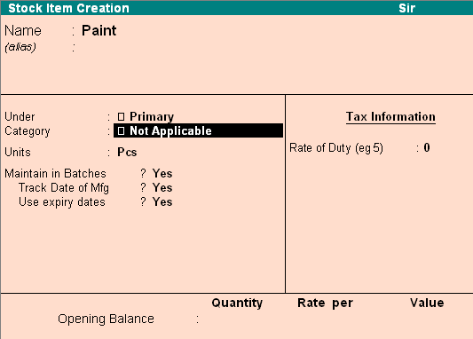

- Batch Manufacturing Date: At Mfg Date (this prompt appears If you have set Yes to Track Date of Mfg for the Item at Item Master) enter the Batch Manufacturing Date.

- Batch Expiry Date: At Exp Date (this prompt appears If you have set Yes at Use Exp Date for the Item at Item Master) enter the Batch Expiry Date.

- Batch Quantity: At Quantity field, enter the Batch Quantity (and UOM) in the Opening Stock.

- Batch Rate: At Rate field, enter the Rate (and Rate UOM).

- Batch Value: At Amount field, the computed Batch Value is displayed (If Rate is entered), which you may change, else enter the Batch Value.

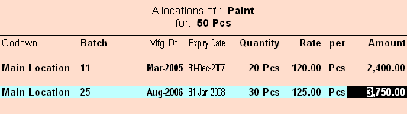

Opening stock Batch details Entry

TALLY VOUCHERS

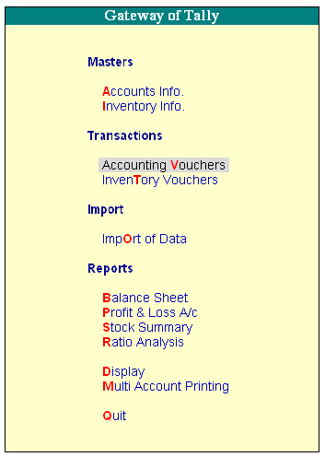
Voucher:

A Voucher is a document that contains details of a financial transaction. For every transaction, you can use appropriate Tally Voucher to enter the details into the ledgers and update the financial position of the company. Mainly there are two types of Voucher entry:

- Accounting Vouchers
- Inventory Vouchers

Voucher Creation Screen of Tally 9 screen is divided into three parts:

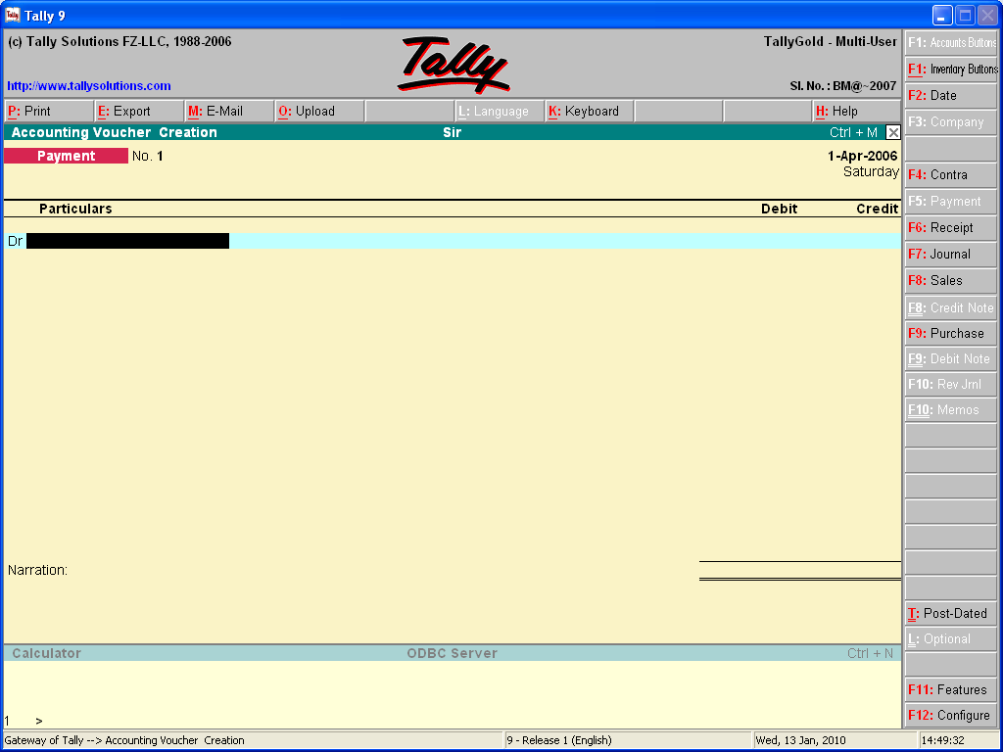

Main Voucher Entry Area: The Main Voucher Entry Area is where you enter all your transactions. This area provides fields for Date, Ledger Name and Amount as well as additional pop-up screens that are dependent on your voucher configuration.

Button Bar Area: The Button Bar area displays buttons that provide quick interaction with Tally.

Calculator Area: The Calculator area provides the calculator functions where you can enter any number of mathematical formulae for complex calculations.

Key strokes for Voucher Narration Field:

- ALT + R: Recalls the Last narration saved for the first ledger in the voucher, irrespective of the voucher type.

- CTRL + R: Recalls the Last narration saved for a specific voucher type. Irrespective of the ledger.

Types of Vouchers: Tally 9 is pre-programmed with a variety of accounting vouchers, each designed to perform a different job. The standard vouchers are:

- Payment Voucher
- Receipt Voucher
- Contra Voucher
  - Sales Voucher
Sales Orders
Sales Vouchers/Invoices
Delivery Notes
Rejection In
- Purchase Voucher
Purchase Orders
Purchase Vouchers
Goods Receipt Notes
Rejection Out
- Journal voucher
Credit Notes
Debit Notes
Journal
Memo Voucher
Reversing Journal
Stock Journal
Physical Stock

Contra Voucher of Tally 9:

Contra voucher is for entering fund transfer transactions where net inflow and outflow are equal, i.e. net effect is Zero. According to accounting rules, Contra entry is a transaction indicating transfer of funds from:

- Cash account to Bank account.
- Bank account to Cash account.
- Bank account to Bank account.

Advantages of Single Entry Mode:

- Faster data entry.
- Selection of:
  - Multiple Ledgers (to be credited) with a Single Ledger (to be Debited) OR
  - Multiple Ledgers (to be debited) with a Single Ledger (to be Credited) – depending on the nature of transaction.

Setting Double Entry Mode (Contra):

- In this example, we have changed the Dr/Cr instead of To /By
- As the Contra voucher is active, the Buttons of the other voucher types of Payment, Receipt, Journal, Sales and Purchase are visible.

Contra Entry – Double Entry Mode: To select multiple Debit and Credit ledgers in the Double entry mode, set Use Single Entry Mode for Payment/Receipt/Contra to No in F12: Configure.

Payment Entry (F5) in Tally 9: All transactions related to payment (by cash or bank) are recorded in payment voucher. Such payments can be to wards purchases, expenses, acquisition of fixed assets, dues to creditor, loans/advances given by you or repayment of loans/advances taken by you earlier etc. The company settles expenses of conveyance, staff welfare postage and stationery through cash all in one voucher, the entry appears as shown in figure.

Receipt Entry (F6) in Tally 9: All inflow of money (in cash or through Bank) is recorded through Receipt voucher. Such receipts may be towards any income of from your debtors or loans/advances given earlier etc.

Journal Entry (F7) in Tally 9: Journal entries are used in instances where the company requires adjusting the debit and credit amounts without involving the cash or bank accounts. Hence, they are also referred to as adjustment entries.

Sales Entry (F8) in Tally 9: All credit sales transaction (whether for goods or services) are entered in sales voucher. In case of cash sales, you receive payment immediately by cash or by cheque or credit card and since you do not require to track outstanding (as payment has already been received so there is no need to create a separate ledger for the buyer who has paid immediately.

Purchase Entry (F9) in Tally 9: All credit purchase transaction (whether for good of services) are entered in purchase voucher. In case of cash Purchases, you make payment immediately by cash or by cheque or credit card and since you do not require to track outstanding (as payment has already been made so there is no need to create a separate ledger for the seller who get paid immediately.)

Entering Vouchers:
The Voucher Entry Screen:

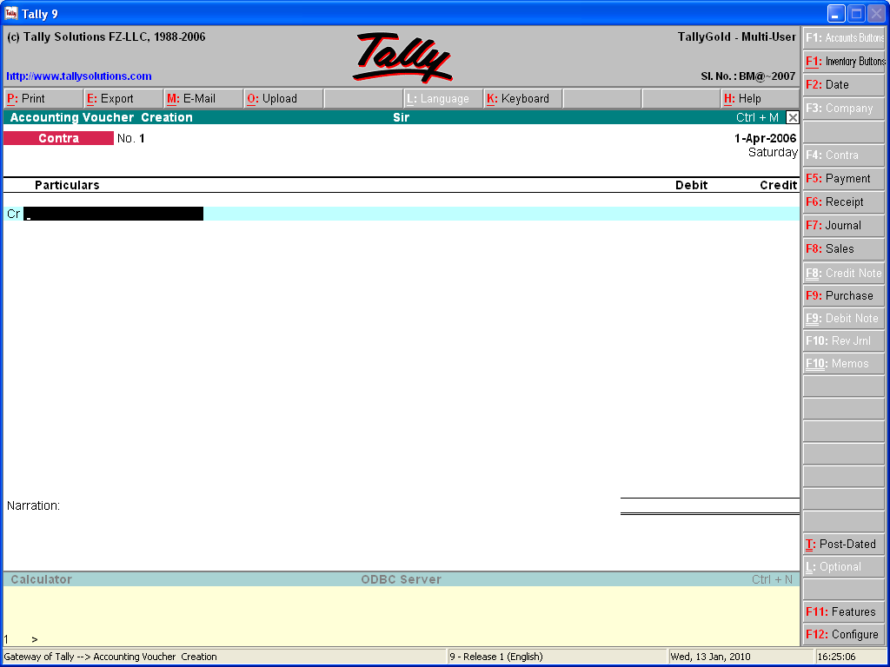

The main voucher entry area: This is where you enter your transactions this screen contains fields for date, ledger name and amount as well as additional pop-up screens that are dependent upon your voucher configuration.

Direct Commands area: Displays the commands you type into this area, and in the current version of Tally, is limited to calculator functions.

Buttons Toolbar: Displays buttons that provide quick interaction with Tally. Only buttons relevant to the current screen will be visible.

Switching between screen areas: On selecting voucher entry from the Gateway of .Tally, you are taken to the main voucher entry area. However, you may toggle between this and the direct commands/calculator area at the bottom of the screen, by pressing [Ctrl] + [N] or [Ctrl] + [M] as indicated on the screen. [Ctrl] + [N] To go to

the calculator [Ctrl] + [M] for the voucher entry area. Use calculator by [Alt] + [C] when in amount field.

Contra Entry (F4):

Gateway of Tally > Accounting Vouchers > Select F4: Contra.

Example: Cash deposited into the bank Rs.3000/-

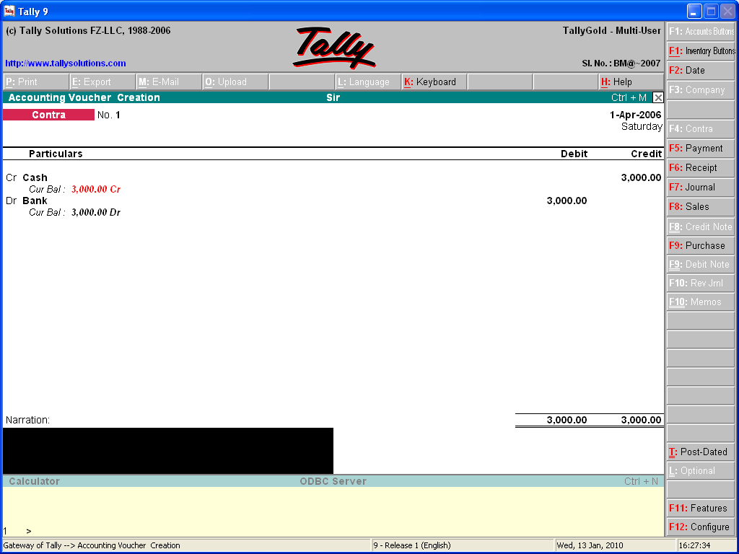

Payment Entry (F5):

Gateway of Tally > Accounting Vouchers > Select F5: Payment.

Example:
- Salary and Rent paid Rs.65000/- Rs.5000/-

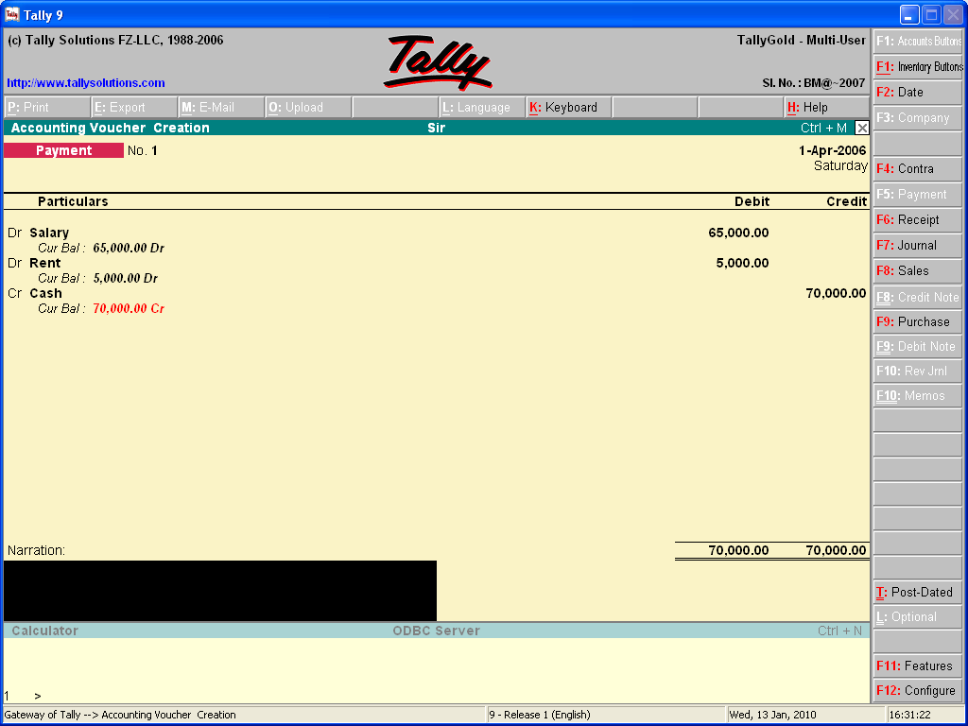

Receipt Entry (F6):

Gateway of Tally > Accounting Vouchers > Select F6: Receipt.

Example:
- Comm. Received from Ram Rs.5000/-
- Interest Received Rs.250/-From HDFC bank

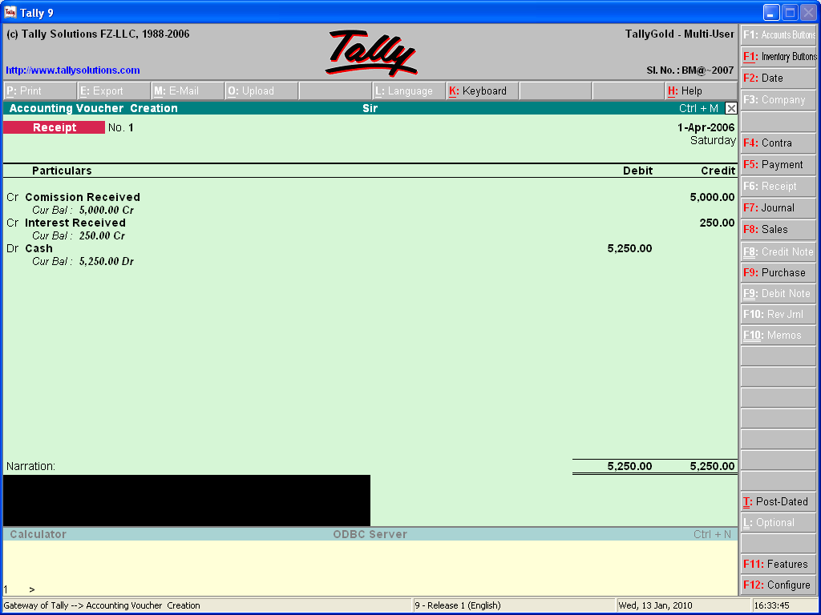

Journal Entry (F7):

Gateway of Tally > Accounting Vouchers > Select F7: Journal.

Example:
Depreciation on Machinery & Computer Rs. 1,450/- & Rs.450/-

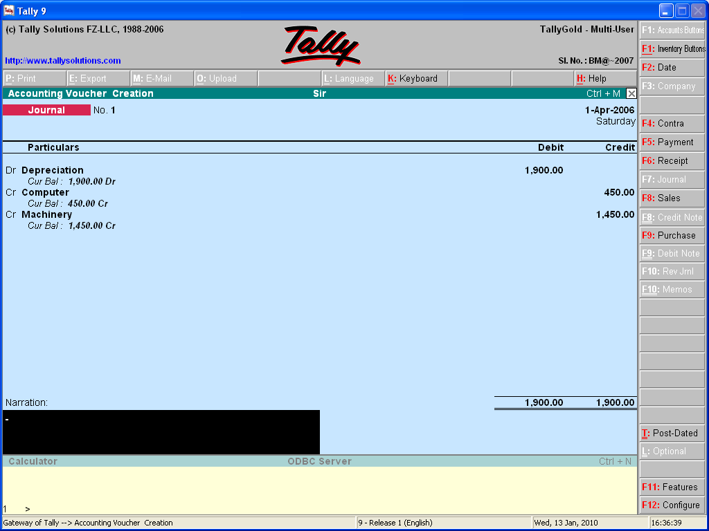

Sales Entry (F8):

Gateway of Tally > Accounting Vouchers > Select F8: Sales.

Example:
Goods sold worth Rs.5000/-to XYZ & co. on credit.

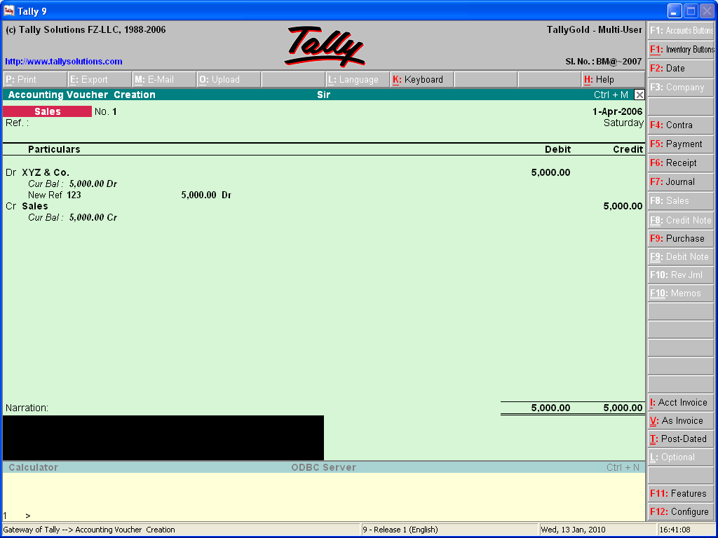

Purchase Entry (F9):

Gateway of Tally > Accounting Vouchers >Select F9: Credit note.

Example:
Goods Purchase worth Rs. 3500/- from Shyam & Sons on credit.

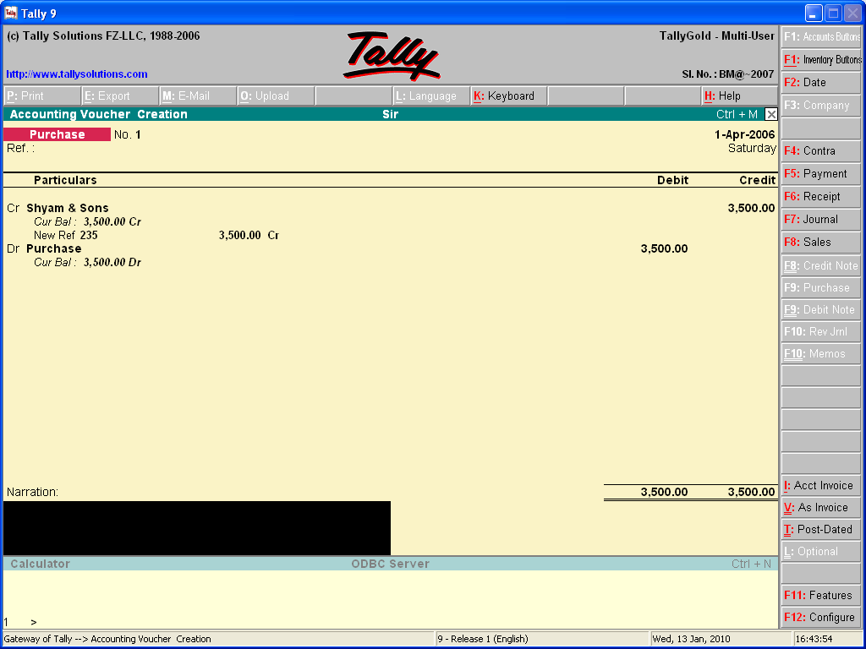

Buttons of Voucher Screen:

F2: Date – You can use this button to change the date of the voucher.
F3: Company – Therefore, you can, almost simultaneously enter vouchers for more than one company.

Accounting Vouchers:

F4: Contra Voucher
F5: Payment Voucher
F6: Receipt Voucher
F7: Journal. This is split into Journal, Debt Notes and Credit Notes
F8: Sales
F9: Purchase
F10: Memos
F7: Stock Journal
F10: Phys.Stock. This allows recording of physical stock in hand as distinct from computed stock figures.

Other Buttons:

As Invoice: Available only in the sales voucher screen.

Post Dated: To mark the current voucher post dated.

Optional: To mark the current voucher optional. Toggles with Regular

F11: Feature
F12: Configure

Cost Category and Cost Center:

Tally’s concept of cost centers allows an additional dimension to a transaction. By providing cost centers. A transaction can be allocated to it which would then enable extraction of all transactions for a cost centre. Tally gives you the cost centre break-up of each transaction as well as details of transactions for each cost centre. When you also allocate income to the units, they become profit centers. You can now obtain a profit and loss account of each such profit centre. For your purposes, the terms cost centre and profit centre are interchangeable.

Cost Centers: Tally’s concept of Cost Centers allows an additional dimension to a transaction. While a ledger account would indicate the nature of a transaction, it would not readily disclose, except in the narration, which part of an organization was involved.

Examples of cost centers:

- Departments of an organization, e.g., Finance, Manufacturing, Marketing, etc.
- Even individuals like, Salesman A, salesman B, etc.

Cost Categories (For advanced usage only): Cost Categories have been introduced for organizations requiring allocation of resources to parallel sets of cost centers. Such organizations would usually be project oriented.

Use of Cost Categories: If it were not for cost categories, there would be only one set of cost centers, e.g., only one set of primary cost centers with each primary cost centre having its own subsidiaries. By using cost categories you may allocate, in parallel, a transaction to more then one set of cost centers.

Cost Categories: Departments Executives Projects
Cost centers: Manufacturing Salesman A Airport cont.
Marketing Salesman B Road const.
Finance Salesman C Building

Creation of Cost Categories:

Gateway of Tally > Acct. Info. > Cost Categories > Create.
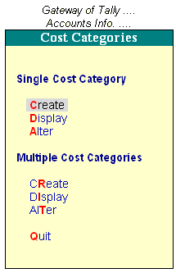

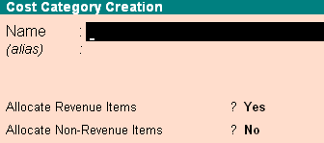
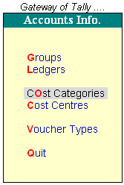

Cost Center Classes: The purpose of cost centre Classes is to facilitate predetermined allocation of ledger accounts (like expenses and incomes) to cost centers during voucher entry.

Setup Required for Cost Center Classes: Before you select classes, it is advisable to create the cost centre structure. Hence, create your cost categories and cost centre before creating classes.

Creations of Cost Center Classes: At the gateway of tally, select F11: company features (F1) set yes at use predefined cost centre allocation during voucher entry.

Voucher Entry with Cost Classes: Each voucher now contains the cost Class option at its head. Select not applicable in case you want to allocate manually. Select a cost class to auto-allocate according to the predefined percentages set in that class. Now enter the voucher as usual. The cost centre allocation sub- screen will not come up and the allocation will be done automatically in the background.

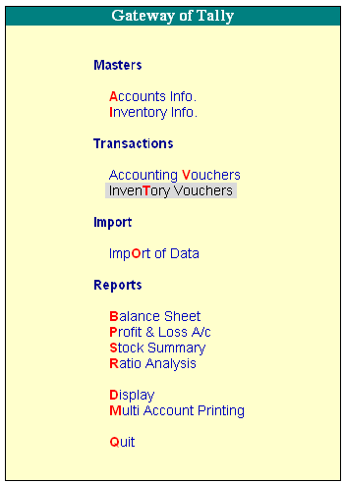
Inventory Vouchers:

Inventory Vouchers perform the same function in the inventory system just as accounting vouchers do in the accounting system. Inventory Vouchers are also means of entering transactions. Inventory vouchers record the receipt and issue of goods/stock, the transfer of stock between locations and physical stock adjustments.

Types of Inventory Vouchers:

Tally is pre-programmed with Inventory Vouchers of various natures, each designed to perform a different task. The following table displays the standard Accounting Vouchers provided in Tally and their corresponding activation key combination and buttons.

Key Combination Buttons Voucher Type

ALT + F9 F9: Rcpt Note Receipt Note Voucher
ALT + F8 F8: Dely Note Delivery Note
ALT + F6 F6: Rej. Out Rejections Out
ALT + F6 F6: Rej. In Rejections In
ALT + F7 F7: Stk Jrnl Stock Journal Voucher
ALT + F10 F10: Phys Stk Physical Stock
ALT + F5 F5: Sales Order Sales Order
ALT + F4 F4: Purc. Order Purchase Order

Set the option Use Tracking Numbers to Yes in F11: Company Features to activate Goods in Receipt Note and Goods out Delivery Note vouchers.

Receipt Note Voucher: For recording goods received. For example, the company receives new stock from a supplier.

Rejections-In Voucher: For recording goods received back that was rejected by a customer.

Delivery Note Voucher: For recording goods delivered to a customer. For example, the company delivers goods from stock to a customer.

Rejection-Out Voucher: For recording of goods that are rejected and returned to a supplier.

Stock Journal Voucher: For recording stock transfers from one location to another.

Physical Stock Voucher: For recording actual stock as physically verified or counted.

Enabling F11: Features for Inventory Vouchering:

- Set Use Tracking Numbers to yes to activate Delivery Note and Receipt Note vouchers.
- Set Use Rejection Notes to yes to activate Rejections In and Rejections Out vouchers.
- Set Allow Purchase Order Processing and Allow Sales Order Processing to yes to activate Purchase Order and Sales Order vouchers.
- A typical Receipt Note inventory voucher screen appears as shown below: The screen is divided into three sections

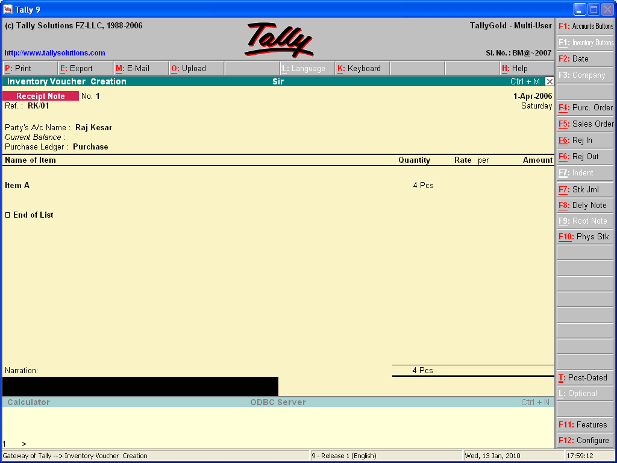

- The Type, Reference and Date of the Voucher.
- Party’s Particulars and Ledger Account.
- Inventory Item Details.

Type of Vouchers:

You need to check you are using the right voucher for the transaction. You change the voucher type by selecting the new type from the button bar. In some cases, like receipt notes you will see a pop-up screen from which you select the right voucher.

Purchase Order: Purchase Order details will also depend on configuration settings. Hence, have a look at the configuration and voucher types.

Gateway of Tally > Inventory Vouchers > Select Purchase Order.

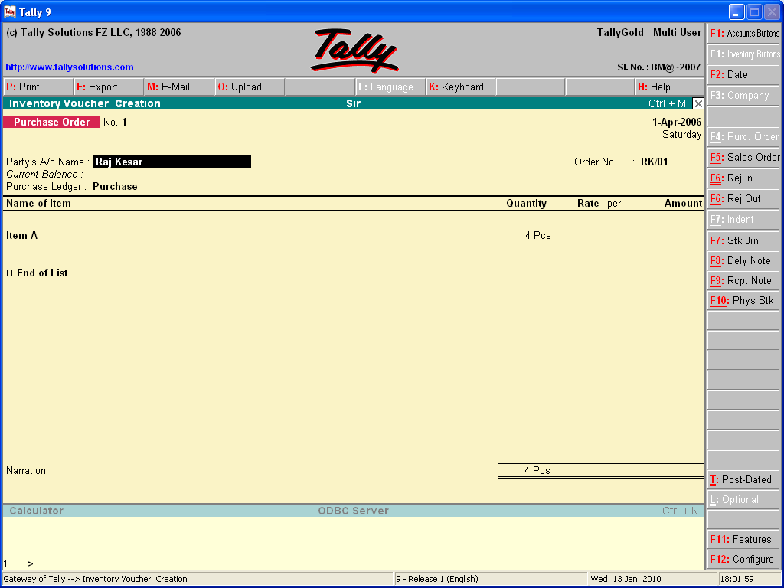

Party’s A/c Name: Give the supplier’s name. Type in the same manner as voucher entry and select from list of Ledger Accounts.

Order No: The voucher number can be treated as your Purchase Order number. You may configure the voucher type through Inventory info.> Voucher Types to set prefixes and suffixes for purchase Orders.

Name of the Item: Give the name of the stock item for which the order is to be placed. Once the name is given the Item Allocations sub-screen pops-up that needs to be filled in.

Additional Cost Details: An additional cost on the item may be incurred which can be mentioned here. Give by way of percentage of the item cost or a flat amount. If not, select End of List.

Next Item: The cursor then comes to the Item field once again and you can enter another item to order. If no other item is required, press [enter] on the blank field to take the cursor to the tax/ expense field.

Narration: Optional. You may give some particulars about the order.

Alter a Purchase Order: You can alter a purchase order by displaying it from a variety of place but is easier through the purchase orders Book or the Day book.

Gateway of Tally > Display > Day Book.

OR

Gateway of Tally > Display > Inventory Books > Purchase Orders Book.

Delete a Purchase Order: Alter an order a use [alt] + [D] to delete it.

Receipt Note Voucher: For recording goods received. For example, the company receives new stock from a supplier. If a purchase order. Exists for that supplier, selecting it will bring up the order particulars.

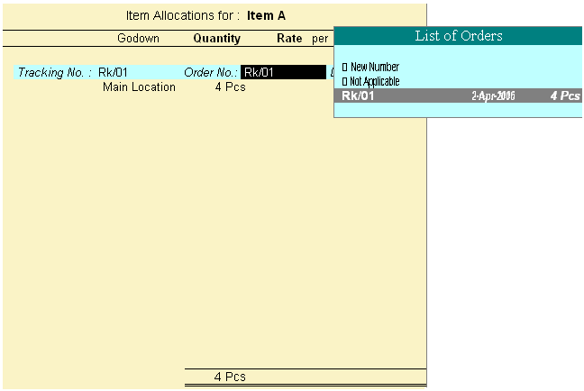

Goods received against purchase order.

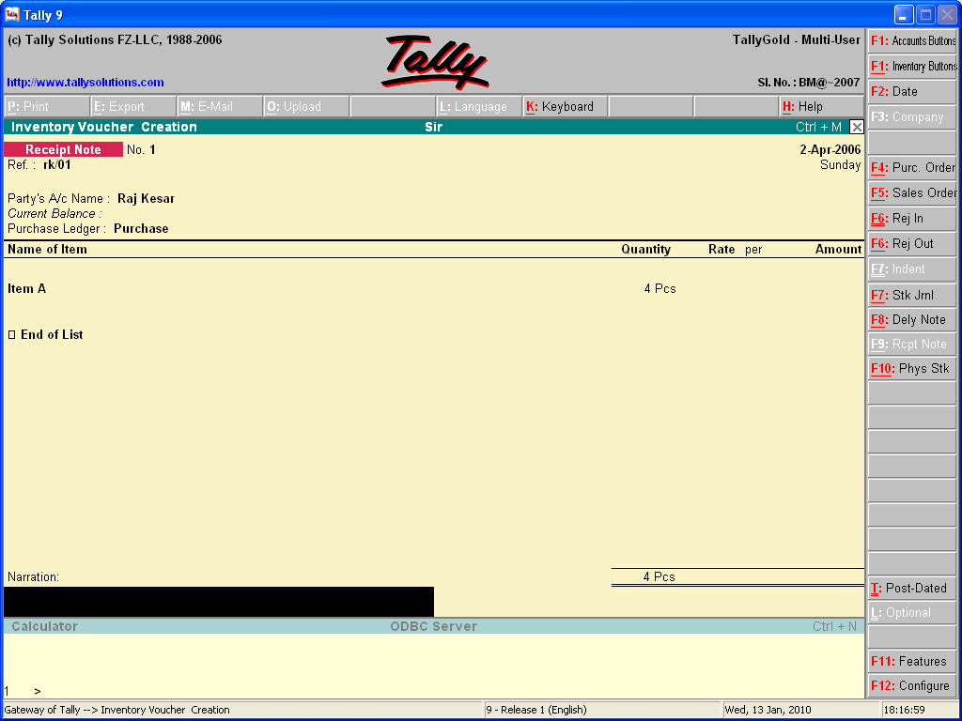

Rejections-Out Voucher: For recording of goods that are rejected and returned to a supplier. For example, the company returns items that had previously been taken into stock to the supplier.

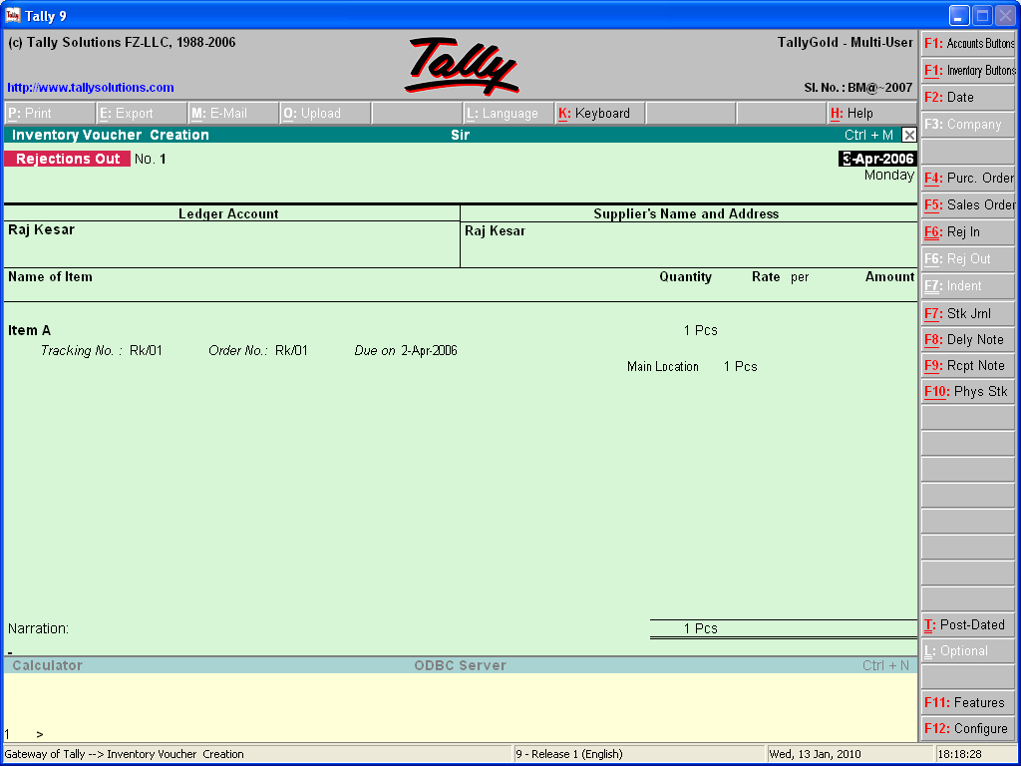

Stock summary is perhaps the best place to view the order position.

Gateway of Tally > Stock Summary > Detailed [F1]

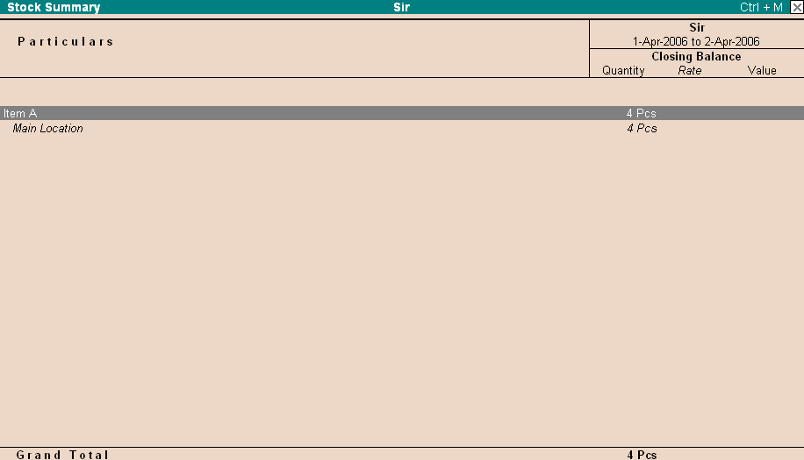

Sales Order: Tally permits you to produce Sales orders from the system. Sales orders received are recorded in sales order entry screen. The details are available during Delivery note and invoicing.

How to create Sales Orders: Sales order entry exactly like Purchase Orders.

Gateway of Tally > Inventory Vouchers > Select Sales Order.

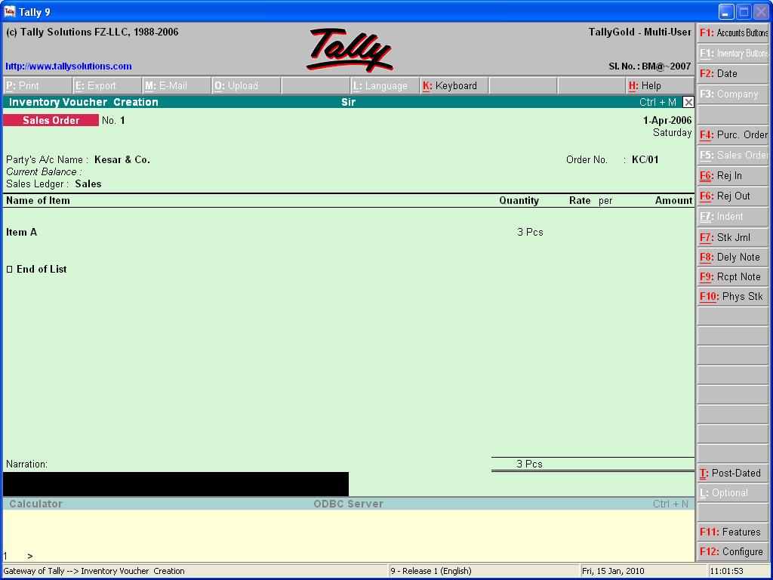

Alter a Sales Order:

Gateway of Tally > Display > Day book

Or

Gateway of Tally > Display > Inventory Books > Sales Order Books.

Delivery Note Voucher: For recording goods delivered to a customer. For example, the company delivers goods from stock to a customer. If a sales order exists for that customer, selecting the appropriate sales order will bring up the relevant particular goods delivered against the sales order.

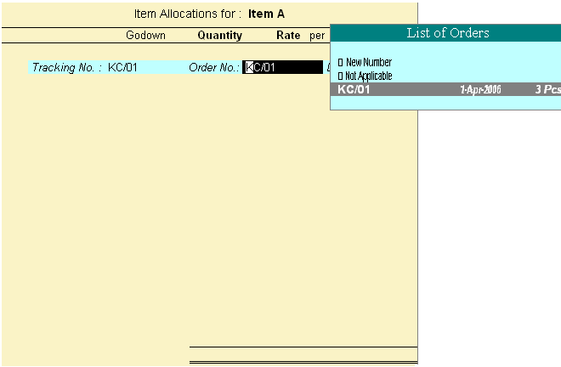

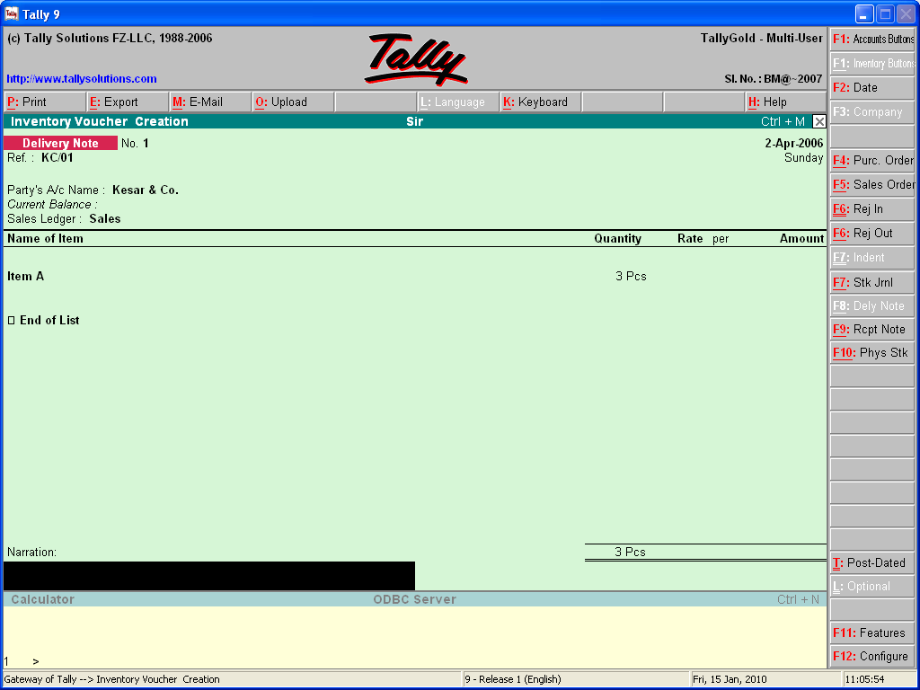

Rejection-In Voucher: For recording goods received back that was rejected by a customer.

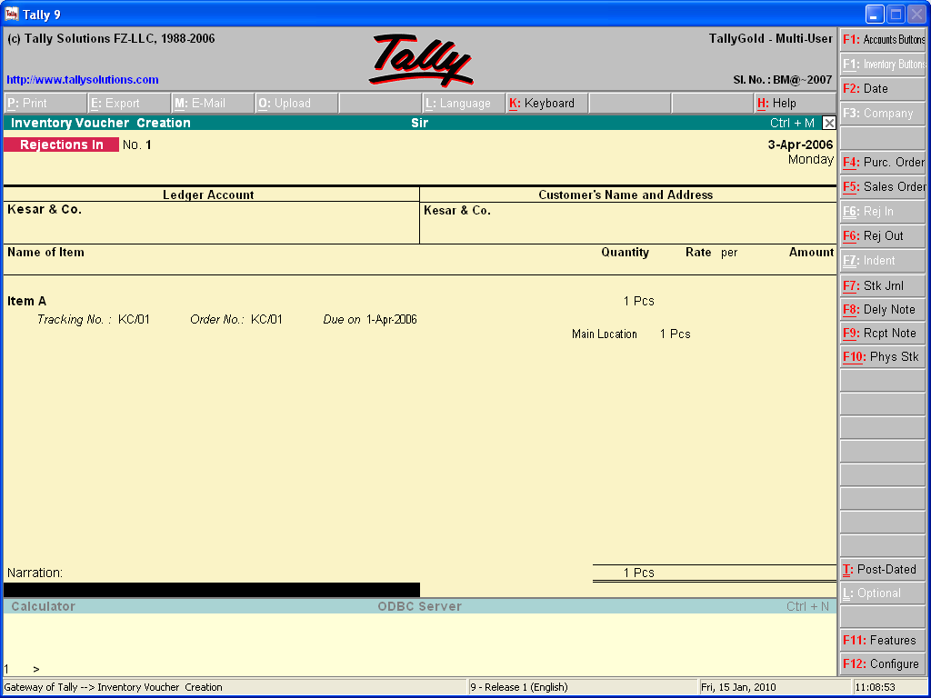

View Order Position: Stock summary is perhaps the best place to view the order position.

Gateway of Tally > Stock Summary > Detailed [F1]

Stock Journal Voucher:

For recording stock transfer from one location to another. For example, the company transfers items of stock from the warehouse to the shop.

How to create a Stock Journal:

Gateway of Tally > Inventory Vouchers > [Alt] + F7 or Click on Stock Journal.

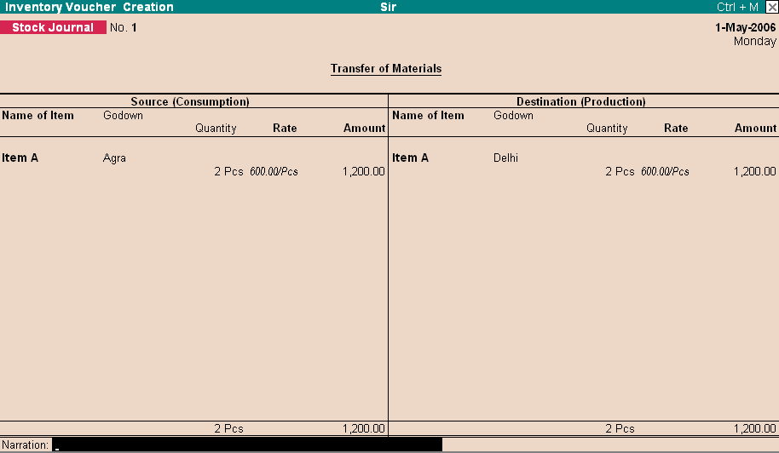

Unit-7 Voucher Type and Class

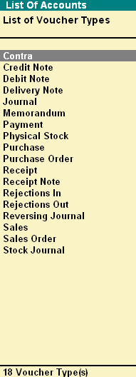
Voucher Type:

A voucher is the primary online document for recording transactions. Transaction recording and analysis are greatly facilitated by having specific formats for different types of transactions. Tally provides 18 different predefined voucher formats of what are calls predefined types of vouchers. These are used for recording various transactions.

Gateway of Tally > Display > List of Accounts > [Ctrl] + V Voucher Type.

How to Manage and Operate Voucher Type:

Tally acknowledges the special requirements of some users for more voucher types. These arise in cases like when you need the same voucher but in different names or separate series of numbers.

Examples include cash payment vouchers and Bank payment vouchers where the relevant predefined voucher is payment voucher. You may have two or more of sets of sales vouchers for different kinds of sales transactions e.g. Credit sales, Cash sales, etc.

Create a Voucher Type:

Gateway of Tally > Account Info. > Voucher Type > Create.

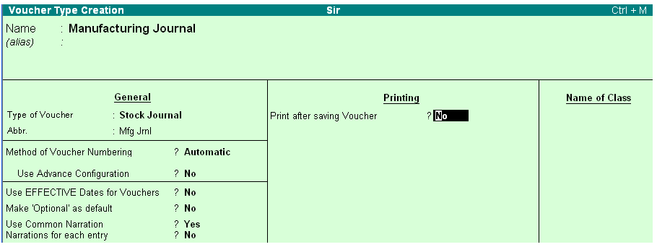

Name: Give the name of the new voucher type, e.g., bank payment voucher.

Type of Voucher: The type of voucher should be any one of the predefined voucher types (already listed in introduction).

Abbreviation: An abbreviation is required particularly for unformatted reports, which do not use compressing techniques. (Tally allows renting of both formatted and unformatted reports).

Method of Voucher Numbering:

None: This will disable numbering of such vouchers. If you select this method, no further information is required.

Manual: This method will allow you to number voucher of this type yourself. It does not check for sequence of the numbers and permits.

Automatic: This method is both flexible and exhaustive. Use it carefully to give you your desired numbering system. Select this option to let Tally number the vouchers automatically for you.

Use Advance Configuration: Press Y to define additional information about voucher type. It will show you a new window where you can provide following information.

Starting number : Give the number for the first voucher. Usually it is 1. You can
set it to any number you want.

Width of Numbering Part : You may leave it blank to let Tally automatically adjust the
width according to the number.

Pre fill with ZERO : When the width is specified, the digits before the number is
blank if ‘No’ and zeros if ‘Yes’. E.g. 0010.

Restart Numbering Voucher : Numbering may be restarted with the starting number (as
specified) at intervals selected by you- Monthly, Yearly or
never.

Prefix Details : If you want the voucher numbers to be prefixed with some
fixed information, give the information here.

Suffix Details : You can also vive fixed suffix informant on for the voucher
number.

Use Effective dates for vouchers: To the enter effective dates for voucher. You would opt for this if you have instances where a transaction under consideration for overdue/ageing analysis is recorded currently but will take effect from another date.

Use common narration: A common narration for the entire voucher. Tally vouchers can have multiple entries.

Narration for each entry: A separate narration for each entry of a voucher. This would be applicable for a multiple entry voucher where you want separate details for each entry.

Print after saving voucher: If you want to print every voucher after entering it.
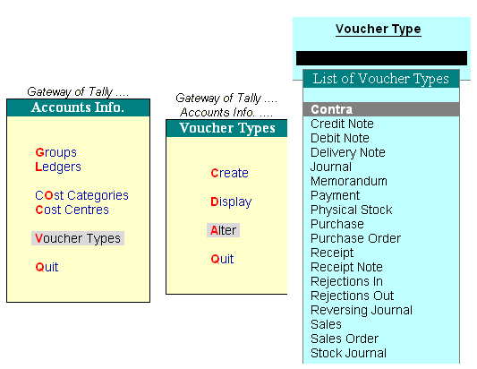
Voucher Classes:

Voucher Class for Payment, Receipt and Contra Voucher:

The Primary intention of using classes for payment, receipt and contra vouchers is to enable data input in ‘single entry’ or list mode rather than in Tally’s traditional double entry mode.

Creation of Voucher Class:

Gateway of Tally > Account Info. > Voucher Type > Alter > Select Payment.

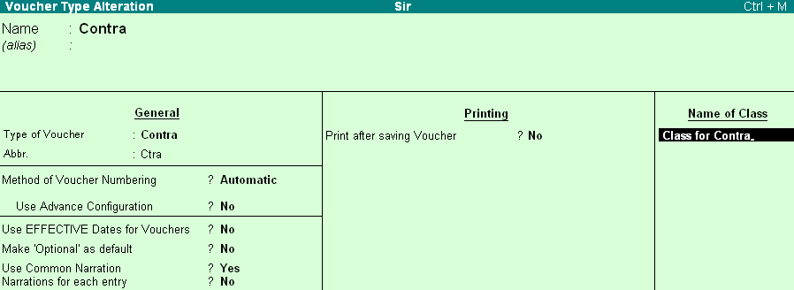

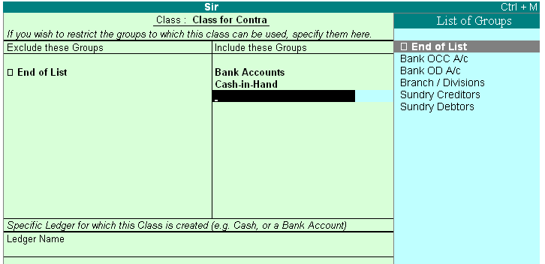

Exclude these Groups: Groups other than Bank or Cash groups should not be selected. This is used to exclude Cash or bank Groups that are not to be used in this class to pay out the money.

Include These Groups: Groups other then bank or cash groups should not be selected. You might exclude a top level group but include its sup- group.

Ledger Name: Selecting the ledger account that will be used to pay out the money will eliminate the need to select it during entry. In this case, it is barcSlays bank. In a receipt voucher, you will select the ledger account into which monies will be received. You may even select ‘Not Applicable’.

Payment Voucher Entry with Classes: Select voucher Entry at the gateway of tally. Press F5: Payment. You have to select a class or not applicable if no class is desired for this entry. If cost centre Class has been set, it can be selected too.

The voucher class is petty cash. Name that you do not have to select the cash/bank account and the entries are not in the regular Dr/Cr format. Data entry in Tally was already very rapid. It is now faster than before!

Purchase and Sales Voucher Classes: Purchase voucher Classes are templates where you can restrict accounts to be used in entries as well as automate accounting entries for items and expenses.

Default Accounting Allocation: Each stock Item in the invoice can be allocated to the financial (nominal) account mentioned here. Hence, all the stock items that will be entered in this class will automatically affect this nominal ledger account. Of course, the stock item record remains as it is an can be viewed separately.

Ledger Name: Select the ledger to be credited for each item sold in the invoice. More than one ledger can be affected for each item, e.g. for tax-inclusive items.

Percentage %: Useful in tax-inclusive price cases, you can specify the sales ledger account as, say, 82.5% and in the next line the Tax account with the balance 17.5%. Normally, for tax-exclusive prices, you will give 100% for the sales account. The % symbol is required to be mentioned.

Rounding Method: This may be used only where the sales account is Not 100%. Calculated amounts may be required to be rounded off up upwards of downwards or normal. Normal is rounding to the number of decimal places specified for the currency based on the less than 5 & greater than 5rule. You can set your own rounding off rule e.g. round off to the next whole number. In such a case, you will give upwards.

Rounding Limit: For the previous example, you will set it to 1 to achieve the amount to round off upwards to the nearest 50p, you will set it to 0.50.

Override using Item Default? This question to be answered Yes or No. Item default here refers to the sales ledger account that you may have set for a stock item, e.g. for computers sale of finished goods. If in the class table here, you mention sales local.

Additional Accounting Entries: Expenses and other charges like Impart Duty, Freight, VAT, Sales Tax can be specified here which will be calculated automatically on the Type of calculation and value basis.

Ledger Name: This is self explanatory. You can give more than one ledger.

Type of Calculation: Select the type you want for calculations.

As Additional Excise: In the Indian sub-continent, a manufacturing tax, or Excise is levied. For some products, a supplementary levy on the ‘Basic excise duty’ is charged, as ‘Additional excise Duty’. This is a surcharge calculation, For example, an Additional Excise Duty of 10% on the basic duty. While the calculation method is identical to ‘As Surcharge’ (see below), the result is to provide a total excise payable calculation accurately during invoice printing.

As a Flat Rate: When you wish to specify a standard mark-up/down on an invoice independent of the qty /value of the invoice.

As Surcharge: When you wish to calculate the value based on the immediately preceding figure. For example, a sales tax of 10% is applicable on an invoice, which would be calculated on the value of goods sold. On this, a ‘Surcharge’ of 5%-i.e. 5% of the sales tax value is applicable.

As Total Amount Rounding: Typically, this is the last line in an invoice. You would need to create an account, which would carry the ‘rounding difference. Now, as the other values of the invoice are calculated, this account would automatically get adjusted to keep the total invoice value to the desired rounding limits. Normally, you would also mark this invoice as ‘Remove if Zero? Yes.’ So that the account head is not retained in the invoice printouts if no rounding was applicable.

As User Define Value: This allows you to specify a value while creating the invoice itself. Normally, you would use this when the basis of calculation is neither value nor Qty dependent, and therefore, needs to be entered very time you create an invoice.

Based on Quantity: In this case calculations are based on the ‘Total Qty’ supplied. For example, you may have freight or forwarding charges as 2.00/Kg, and if the total qty supplied in the invoice is 200.000 Kg, then the amount should become 400.00.The ‘value basis’ will also need to be provided as 2.00/Kg or 0.50/pc as the case may be.

On Current Sub Total: In certain environments, taxes are applicable on the total goods value as well as supplementary charges such as ‘excise Duty’ Packing charges etc. Normally, when the tax calculation method is specified as on total sales (see below), the calculations are based on the total goods value only. When you

wish the supplementary charges to be included, then you would set on current sup total as the type of calculation.

On Item Rate: Typically used for both VAT as well as excise duty style calculations. Here, you would have specified the rate of tax applicable for each stock Item, and you would want only those items to be used for calculation purposes which equal this rate of tax. The advantage is to be able to mix multiple tax rate products in the same Invoice, and yet get the correct ones picked up for each tax bracket.

On Total Sales: The most common basis of tax calculation is on the total value of goods/ services. This method would calculate using the sum of stock items used in the invoice.

Value Basis: Give the amount which is to be used for the Type of calculation. For percentage, you must use the symbol %. Hence, Tax on sales is 17.5% on Item Rate to use the rate given in the stock Item. The method total amount rounding will round the total invoice and put the difference in the ledger name mentioned here. Hence, the account rounding off will contain the sum that essentially rounds off the invoice to the desired level.

Overview of Tally 9.0.ERP

About Tally – ERP 9:

Tally ERP 9, the latest evolution of the Tally series, has grown from a basic accounting package into a sophisticated business management system. Its comprehensive capabilities meet even the needs of large businesses with dispersed operations.

Tally ERP 9 now provides capabilities invaliding remote access, allowing working from any place, round-the clock. It provides audit & compliance services, integrated support centre and security management. So, the proprietor, manager, CA, consultant and other persons can work from any place at any time, as they like. Yet, it retains its original simplicity, look and feel. It also offers the statutory like Payroll (PF & FPF, ESI, P Tax, and Gratuity etc), Excise, FBT, TDS, TCS, VAT, Sales Tax etc.

Exclusive Features of Tally.ERP 9:

Remote Access Capabilities:

Tally.ERP 9 provides remote capabilities to access data from anywhere. Tally.NET features enable to create remote users, authorize & authenticate them to access company remotely. A remote user can view the information on his system instantly.

Support Centre:

Tally.ERP 9 provides a new Support Centre, wherein a user can directly post his support queries on the functional and technical aspects of the Product. Using Support Centre feature, the user can view all the support queries reported via Support Centre as well as through e-mail, phone calls, etc.

Control Centre

The Control Centre uses Tally. NET as an interface between the end user and Tally. ERP 9 installed at different locations. With the help of Control Centre, the user can:

- Create users with predefined Security levels

- Centrally Configure & manage Tally.ERP 9

- Surrender, Confirm or Reject activation of a Site

- Maintain Account related information

Tax Audit and Statutory Compliance:

Tax Audit:

This feature enables the auditor to quickly and correctly compile information, to assist him in forming an opinion and print Annexure as required for Tax Audit u/s 44AB of I Tax Act.

Auditors’ Edition:

Further, Tally.ERP 9 Gold offers a special Auditors’ Edition, which provides Audit and Compliance exclusively for CAs. Using Auditor’s edition of Tally. ERP 9, CAs can provide Audit and Compliance services to their clients.

Payroll:

Payroll in Tally.ERP 9 is now simplified & enhanced to handle all the functional, accounting and statutory requirements of your business.

Excise for Manufactures:

The new Excise module allows maintaining the required Central Excise records for multiple Excise units of Traders / Manufactures in a single company.

Excise for Dealers:

The Dealer Excise functionality provides fast and error free voucher entry. It helps to track excise duty on each transaction and print invoices with user configurable options & particulars.

Fringe Benefit Tax (FBT):

FBT module calculates the FBT. It also provides Challan management and printing of tax reports.

Value Added Tax (VAT):

VAT is completely integrated with Tally.ERP 9. To make the computation easier, VAT comprises of a pre-defined list of sales and purchase classification.

VAT Composition:

It also provides fast and error-free voucher entry with complete tracking of each transaction. It supports printing of VAT Composition Returns of all the states.

Tax Deducted at Source (TDS):

The TDS features now handle all the functional, accounting and statutory requirements relating to deduction of TDS, deposit with department and printing of TDS Certificates and various TDS reports.

Data Synchronization:

The process of Data Synchronization using Tally Link Server is now changed; Synchronization is now available as a service through the Tally. NET Framework. Users can also use Tally.ERP 9 Silver (Single User) at both the ends to Synchronize data.

New look & feel:

A new look and feel with a new info panel provides 30% more screen space to display information, The info panel at bottom shows current version, latest version that is available from Tally, TDLs running, edition particulars (Auditors’ ,Gold or Silver) and other configuration details (which port the server is listening to, etc.)

Handy features like clicking on the logo takes to the Tally website, clicking on the latest version takes to the ‘downloads page’, etc.)

Four Tally Companies data for comparison can be viewed on a single screen by resizing windows.

Downloading Tally.ERP 9:

The processes to download Tally.ERP 9 are given below:

- Go to Internet Explore and type http://tallysoutions.Com on address bar

- at tally solution.com site, Click on Download to get Downloading Option

- Now Click on Download and save.

- after downloading the software, run the installation

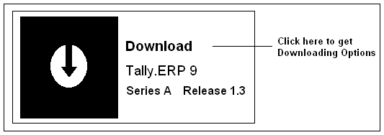

System Requirements:

To Install Tally.ERP 9, you need a computer System with following minimum resources

Processor  Memory  Free Hard Disk Space  Monitor Resolution  Operating System | Intel Pentium IV and above or equivalent  256 MB RAM. 512 RAM MB or higher Ram is recommended  40MB Minimum (Excluding data)  800*600, however 1024*768 or higher is recommended  Microsoft Windows 98/Me/NT/2000/2003/XP/Vista.

Tally.ERP 9 Installation:

The installation process of Tally. ERP 9 is little different from its earlier versions. The steps are described briefly as below:

- Keep the Serial Number and correct e-mail address ready with you.

- Go to site of Tally and download the latest version.

- Run install file and install it in separate folder.

- Surrender the earlier version of Tally9.

- Now follow the Installation process as described below:

  - Insert the Tally Software CD in Drive and Click install.exe.

  - Tally.ERP9 Setup Wizard Welcome Screen appears, Click Next to get Tally.ERP 9 Setup screen

  - In Tally.ERP 9 Setup screen, you may accept the default Settings or change the settings (Application, Data, Configuration, Language or License Directory respectively), Click Next

  - After the set up process is over (a progress bar is shown), The Country/Language Selection screen will be displayed. Now select the Country option (e.g. India / SAARC). Click Next

  - During installation, you get a progress bar showing the progress of installation. Wait to complete the process

  - If you are prompted for the language support files in the Files needed screen, remove Tally CD and insert Windows Operating System CD, or browse for the files if the files are installed in the system.
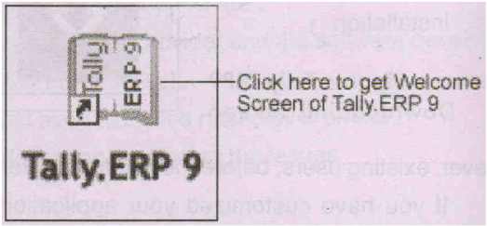
  - After completing the installation process, Click Finish button and get back to the desktop. The Tally icon will appear in the Desktop and Taskbar.

Shortcuts

Shortcuts:

The shortcut Keys appear in button names in the button bar (right side of the tally screen). You can either click the button from the button bar or press the relevant function key or character underlined/double-underlined.

Function Key Combination:

WINDOWS FUNCTIONALITY AVAILABILTY

F1 To select a company At all master menu screen
To select the Accounts Button At the Accounting Voucher creation
and alteration screen

F1 (Alt+F1) To select the Inventory Buttons At the Inventory/Payroll Voucher
creation and alteration screen

F1 (Ctrl+F1) To select Payroll Voucher to alter At the Accounting/Inventory voucher
creation or alteration screen.

F2 To change the current date At almost all screens in TALLY
To select Company inventory At F11: Features screen
features

F3 To select the company At almost all screens in Tally
To select Company Statutory & At F11: Features screen
Taxation features

F4 To select the Contra voucher At Accounting/Inventory Voucher
creation and alteration screen

F5 To select the Payment voucher At Accounting/Inventory Voucher
creation and alteration screen

F6 To select the Receipt voucher At Accounting/Inventory Voucher creation and alteration screen

F7 To select the Journal voucher At Accounting/Inventory Voucher creation and alteration screen

F8 To select the Sales voucher At Accounting/Inventory Voucher creation and alteration screen

F8 To select the Credit Note voucher At Accounting/Inventory Voucher creation and alteration screen

F9 To select the Purchase voucher At Accounting/Inventory Voucher creation and alteration screen

F9 To select the Debit Note voucher At Accounting/Inventory Voucher creation and alteration screen

F10 To select the Reversing Journal At Accounting/Inventory Voucher
voucher creation and alteration screen

F10 To select the Memorandum voucher At Accounting/Inventory Voucher creation and alteration screen

F11 To select the Functions and Features At almost all screens in TALLY
screen

F12 To select the Configure Screen At almost all screens in TALLY

Special Key Combination:

WINDOWS FUNCIONALITY AVAILABILTY

Alt + 2 To duplicate a voucher At list of Vouchers – creates a
voucher similar to the one where you
positioned the cursor and used this
key combination

Alt + A To Add a voucher At list of vouchers – adds a voucher
After the one where you positioned
The cursor and used this key
Combination

To alter the column in columnar Alter the column in all the reports
report which can be viewed in columnar
format

Alt + C To create a master at a voucher At voucher entry and alteration
screen (if it has not been already screens, at a field where you have to
assigned a different function, as in select a master from a list. If the
reports like Balance Sheet, where necessary account has not been
it adds a new column to the report created already, use this key combination to create the master
without quitting from the voucher screen

Alt + D To delete a voucher At voucher entry and master (Single)
Alteration screens. Master can be deleted subject to conditions, as
explained in the manual

To delete a master
To delete a column in any columnar All the function, as explained above
report (if it has not been already reports screen which can be viewed
assigned a different function in columnar format

Alt + E To export the report in ASCII, HTML At all reports screens in TALLY
or XML format

Alt + I To insert a voucher At list of vouchers inserts a voucher
before the one where you positioned
the cursor and used this key
combination.

To toggle between Item and At creation of sales and purchase
Accounting Invoice invoice.

Alt + L To select the language configuration At almost all screens in TALLY

Alt + K To select the keyboard configuration At almost all screens in TALLY

Alt + O To upload the report at your website At all reports screens in TALLY

Alt + M To Email the report At all reports screens in TALLY

Alt + N To view the report in automatic At all the reports where column can
column be added

Alt + P To Print the report At all reports screens in TALLY

Alt + R To remove a line in a report At all reports screens in TALLY

Alt + S To bring back a line you removed At all reports screens in TALLY
using Alt + R

Alt + U To retrieve the last line which is At all reports screens in TALLY
deleted using Alt + R

Alt + V From Invoice screen to bring stock At Invoice screen
journal screen

Alt + W To view the Tally Web browser At all reports screens in TALLY

Alt + X To cancel a voucher in Day Book At all reports screens in TALLY
/List of vouchers

Alt + Y To Register Tally At almost all screen in TALLY

Ctrl + A To accept a form wherever you use At all reports screens in TALLY
this key combination, that screen or except where a specific detail has to
report gets accepted as it is be given before accepting

Ctrl + B To select the Budget At Groups/Ledgers/Cost Centers/
Budgets/ Scenarios/Voucher Types/
Currencies (Accounts Info) creation
and alteration screen

Ctrl + Alt + B To check the company statutory At all the menus screens
details

Ctrl + C To select the Cost Centers At Groups/Ledgers/Cost Centers/
Budgets/Scenarios/Voucher Types/
Currencies (Accounts Info) creation
and alteration screen

To select the Cost Centers At Stock Groups/Stock Categories/
Stock Items/Reorder Levels/
Godowns/Voucher Types/Units of Measure (Inventory Info) creation/
alteration screen

Ctrl + E To select the Currencies At Groups/Ledgers/Cost Centers/
Budgets/Scenarios/Voucher Types/
Currencies (Accounts Info) creation
and alteration screen

Ctrl + G To select the Group At Groups/Ledgers/Cost Centers/
Budgets/Scenarios/Voucher Types/
Currencies (Accounts Info) creation
and alteration screen

Ctrl + I To select the Stock Items At Stock Groups/Stock Categories/
Stock Items/Reorder Levels/
Godowns/Voucher Types/Units of Measure (Inventory Info) creation/
alteration screen

Ctrl + Alt + I To import statutory masters At all menu screens

Ctrl + L To select the Ledger At Groups/Ledgers/Cost Centers/
Budgets/Scenarios/Voucher Types/
Currencies (Accounts Info) creation
and alteration screen

To mark a voucher as Optional At the creation and alteration of
vouchers

Ctrl + O To select the Godowns At Stock Groups/Stock Categories/
Stock Items/Reorder Levels/
Godowns/Voucher Types/Units of Measure (Inventory Info) creation/
alteration screen

Ctrl + Q To abandon a from wherever you At almost all screens in TALLY
use this key combination, it quits
that screen without making any
changes to it.

Ctrl + R To report narration in the same At creation/alteration of voucher
voucher type screen

Ctrl + Alt + R Rewrite data for a Company From Gateway of Tally screen

Ctrl + S Allows you to alter stock item At stock Voucher Report and
master Godown Voucher Report

Ctrl + U To select the Units At Stock Groups/Stock Categories/
Stock Items/Reorder Levels/
Godowns/Voucher Types/Units of Measure (Inventory Info) creation/
alteration screen

Ctrl + V To select the voucher Types At Groups/Ledgers/Cost Centers/
Budgets/Scenarios/Voucher Types/
Currencies (Accounts Info) creation
and alteration screen

To toggle between invoice and voucher At creation of sales/purchase
voucher screen

Special Function Keys:

WINDOWS FUNCIONALITY AVAILABILTY

Alt + F1 To close a company At all the menu screen
To view detailed report At almost all report screen
To explode a line its details At almost all screens in TALLY
To select inventory vouchers to alter At the Inventory/Payroll voucher
creation or alteration screen

Alt + F2 To change the system period At almost all screens in TALLY

Alt + F3 To select the company info menu At Gateway of Tally screen
To create/alter/shut a company

Alt + F4 To select the purchase order At Accounting/Inventory voucher voucher type creation and alteration screen

Alt + F5 To select the sales order voucher At Accounting/Inventory voucher type creation and alteration screen

To view monthly and quarterly report At almost all report screens in
TALLY

Alt + F6 To select the Rejection Out voucher At Accounting/Inventory voucher
type creation and alteration screen

Alt + F7 To select the Stock Journal voucher At Accounting/Inventory voucher
type creation and alteration screen

To accept all the Audit lists At Tally Audit Listing screen

Alt + F8 To select the Delivery Note voucher At Accounting/Inventory voucher
type creation and alteration screen

To view the columnar report At Ledger voucher screen

Alt + F9 To select the Receipt Note voucher At Accounting/Inventory voucher
type creation and alteration screen

Alt + F10 To select the Physical Stock voucher At Accounting/Inventory voucher
type creation and alteration screen

Alt + F12 To filter the information based on At almost all report screens
Monetary value

Ctrl + F1 To select payroll vouchers for At the Accounting/Inventory voucher
alteration creation or alteration screen

Ctrl + Alt + F12 Advanced Config At Gateway of Tally

Navigation Keys:

WINDOWS FUNCIONALITY AVAILABILTY

PgUp To display previous voucher during At voucher entry and alteration
voucher entry/alter screens

PgDn Display next voucher during voucher At voucher entry and alteration
entry/alter screens

ENTER To accept anything you type into a You have to use this key at most
field. areas in TALLY

To accept a voucher or master

To get a report with further details of At the receivables report press Enter an item in a report at a pending bill to get transactions
relating to this bill (e.g., original sale bill, receipts and payments against this bill, etc)

ESC To remove what you typed At almost all screens in TALLY.
Into a field
To come out of a screen
To indicate you do not want to
accept a voucher or master.

SHIFT+ENTER Collapse next level details At Voucher Register screen and
Trial Balance report

SHIFT+ENTER To explode a line into its details In almost all Reports:
At a Group/Stock Group/Cost
Category/Godown/Stock Category
displays Sub Groups and
Ledgers/Stock Items/Cost
Centers/Secondary
Godowns/Secondary Stock
Categories
At a Voucher displays its entries and narration
At a Stock Item-displays its godowns and batch details
At Voucher Register screen displays the next level details
At Trial Balance report – displays the next level details

CTRL+ENTER To alter a master while making At voucher entry and alteration
an entry or viewing a report screens

