Campus Placement Details
Date: 04/02/2022
Company Name : Just Dial Limited (Justdial)
Type : MBA
Total Register Students : 32
Students Appeared : 11
Students Selected : 03 (02 SET + 01 Other)+02 Waiting
Package Offered : 3 LPA+Incentive
Drive Type : Pool
Colleges Participated : 05
Photograph of Event :
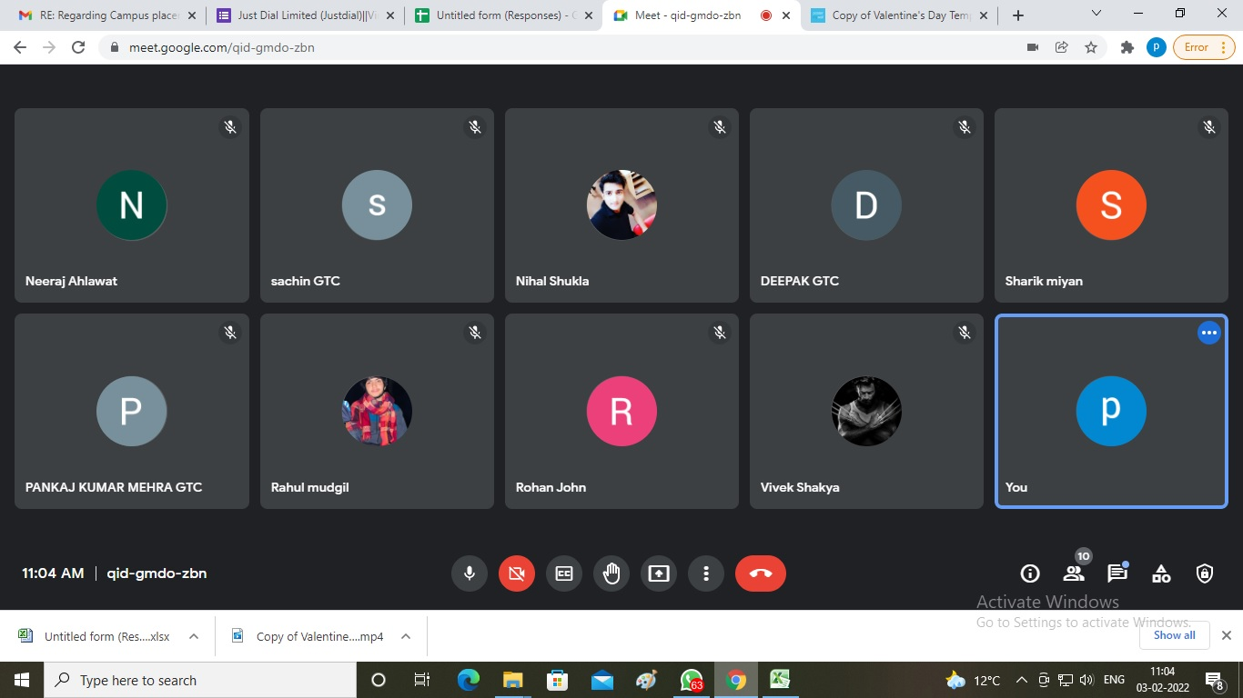

Social Media:
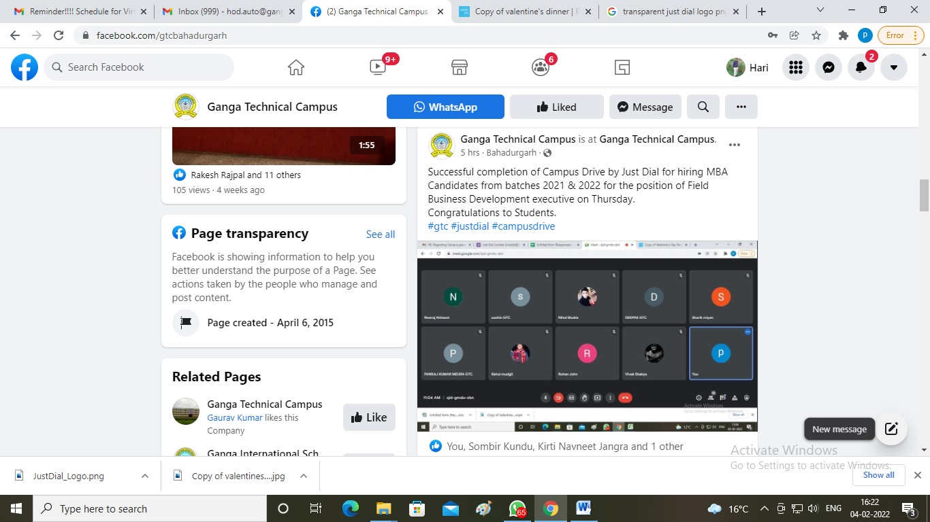

Brief Summary:
On dated 03/02/2022, Just Dial Limited (Justdial) came to the campus placement drive. The HR, executives named Ms. Surbhi Jaiswal & Mr. Pravin Singh were present. 32 students appeared in campus drive. In selection process Interview was held and 03 student selected with 3 LPA package.

Training & Placement Officer

